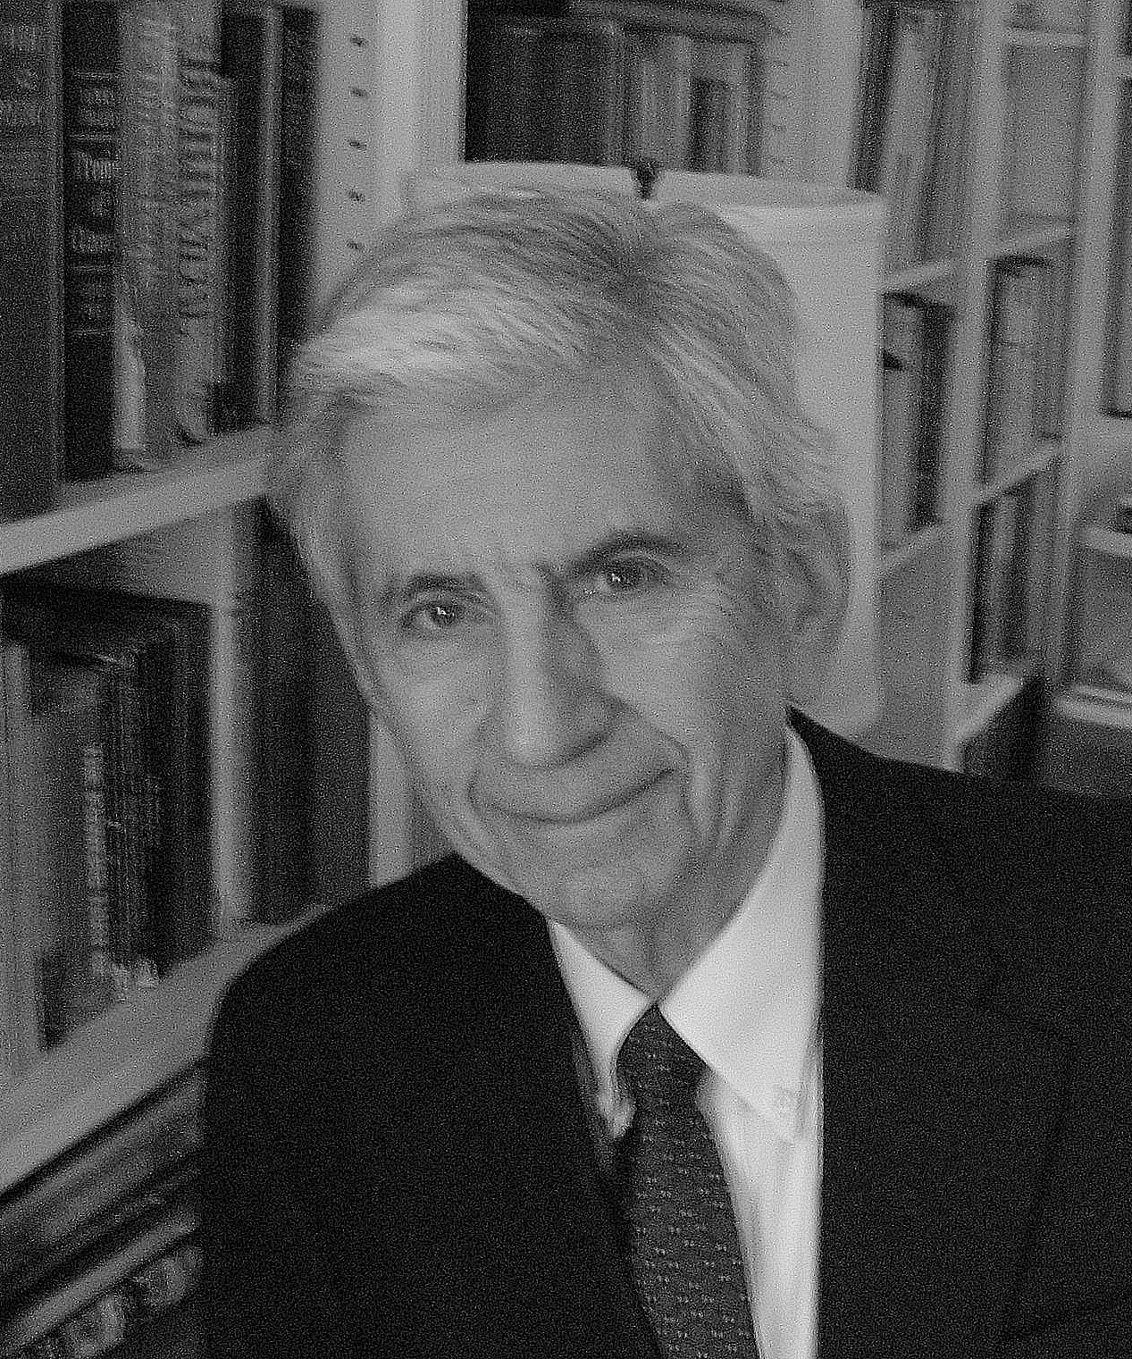
President’s Address – PLENERY SESSION

Kurt Salzinger, Hofstra University
Back-translation: Behavior explained

Much has been made of translational research, particularly since the National Institutes of Health have been supporting it with money, but as we travel from particular basic findings to real life situations such as problematic or abnormal behavior, we have failed too often to engage in back-translation to authenticate the process. This talk will present back-translation of both typical and atypical behavior in real life.
Biography: Kurt Salzinger, Ph.D. is Senior Scholar in Residence at Hofstra University in Hempstead, N.Y. since January 2003. He was Executive Director for Science at the American Psychological Association 2001 to 2003. He’s been President of the New York Academy of Sciences, has served on the Board of Directors of the APA, and been president of Divisions 1 (General Psychology) and 25 (Behavior Analysis), and of the American Association of Applied and Preventive Psychology. He also served as the first Chair of the Board of the Cambridge Center 1986 – 1988. He is author or editor of 12 books and over 120 articles and book chapters. His most recent book was edited by him and Mark Serper in 2009: Behavioral Mechanisms and Psychopathology. He has varied research interests, including behavior analysis applied to human beings, dogs, rats, and goldfish, schizophrenia, verbal behavior of children and adults and history of psychology. He has both given grants (when a program officer at the National Science Foundation) and received them (when professor of psychology at Hofstra University, Polytechnic University of New York and Principal Research Scientist at the New York State Psychiatric Institute) for his own research. He was Presidential Scholar for the Association for Behavior Analysis and received the Sustained Superior Performance Award from the NSF, the Stratton Award from the American Psychopathological Association, the Most Meritorious Article Award from the Journal of Behavior Therapy and Experimental Psychiatry and most recently the Presidential Citation from the American Psychological Association.

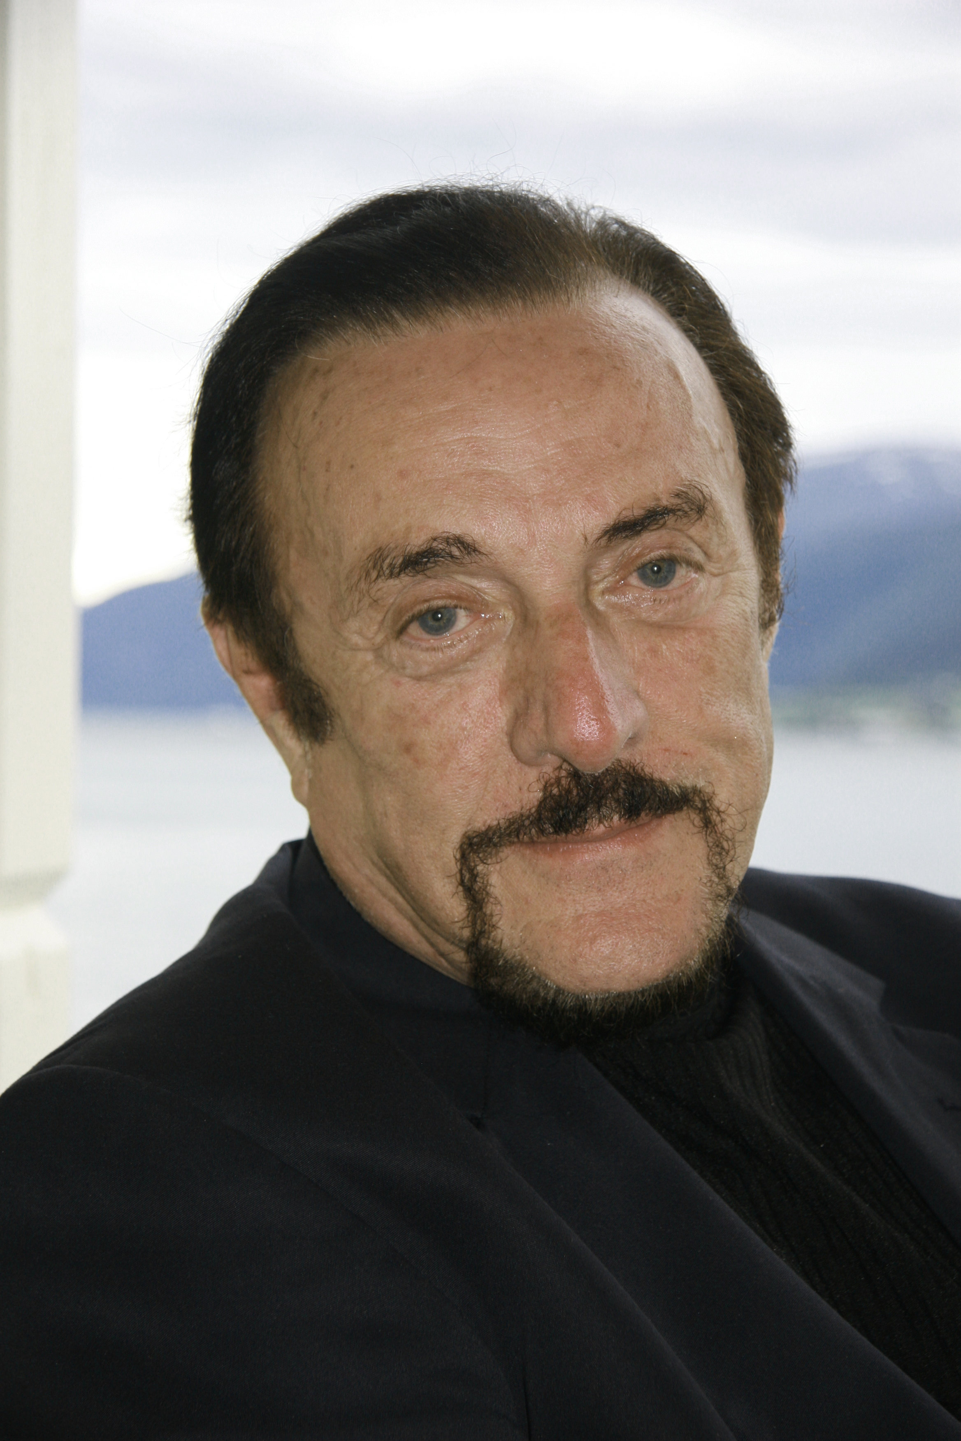
Featured Speaker

Philip G. Zimbardo, Stanford University
My Journey from Evil to Heroism

Biography: Philip Zimbardo is internationally recognized as the “voice and face of contemporary psychology” through his widely seen PBS-TV series, Discovering Psychology, his media appearances, best-selling trade books on Shyness, The Lucifer Effect, and The Time Paradox, as well as his classic research, The Stanford Prison Experiment.
Zimbardo has been a Stanford University professor since 1968 (now Emeritus), having taught previously at Yale, NYU, and Columbia University. He also continues to teach at the Naval Post Graduate School in Monterey courses on the psychology of terrorism, and has begun a new tenure as Professor at the Pacific Graduate School of Psychology (PGSP) teaching social psychology to clinical graduate students. Zimbardo has been given numerous awards and honors as an educator, researcher, writer, and for service to the profession of psychology. Recently, he was awarded the Havel Foundation Prize for his lifetime of research on the human condition. Among his more than 350 professional publications and 50 trade and textbooks is the oldest current textbook in psychology, Psychology and Life, going into its 18th Edition, and Core Concepts in Psychology in its 6th Edition. His pioneering research on shyness in adults was the first of its kind, as was the shyness clinic that he started in 1977 and continues to serve clients at PGSP. His current passion is exploring and encouraging the “Heroic Imagination.”
Zimbardo has been President of the American Psychological Association (2002), President of the Western Psychological Association, Chair of the Council of Scientific Society Presidents (CSSP), current Chair of the Western Psychological Foundation, as well as the Director of the Center for Interdisciplinary Policy, Education, and Research on Terrorism (CIPERT). He also cooks and does windows.

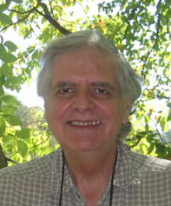
Fred Keller Distinguished Lecture

Thomas Zentall, University of Kentucky
A Model of Addictive Gambling

Humans often buy lottery tickets in spite of the fact that generally they lose more money than they win. The reasons for this maladaptive behavior are complex and may include the inability to calculate or understand the odds, the salience of winning but not losing by others (the availability heuristic), and the possible social reinforcement that may come with winning. But both humans and pigeons show maladaptive gambling behavior, even when given adequate experience with outcomes and under nonsocial conditions suggesting that basic learning processes may be involved.

Biography: Thomas Zentall received his undergraduate degree in electrical engineering and psychology at Union College, Schenectady New York and his PhD from the University of California Berkeley. His first position was at the University of Pittsburgh. He is currently Professor of Psychology at the University of Kentucky where he is DiSilvestro Professor of Arts and Sciences. He has served as President of the Midwestern Psychological Association, President of the Comparative Cognition Society, President of Division 3 (Experimental Psychology) and Division 6 (Behavioral Neuroscience and Comparative Psychology) of the American Psychological Association, Chair of the Governing Board of the Psychonomic Society, and Member of the Board of Directors of the Eastern Psychological Association. He has edited 4 books including, “Social learning: Psychological and biological perspectives,” with Bennet G.Galef, Jr., “Animal cognition: A tribute to Donald A. Riley,” “Stimulus class formation in humans and animals,” with Paul M. Smeets and “Comparative Cognition: Experimental Explorations of Animal Intelligence” with Edward A. Wasserman and he has published extensively in the area of comparative cognition.

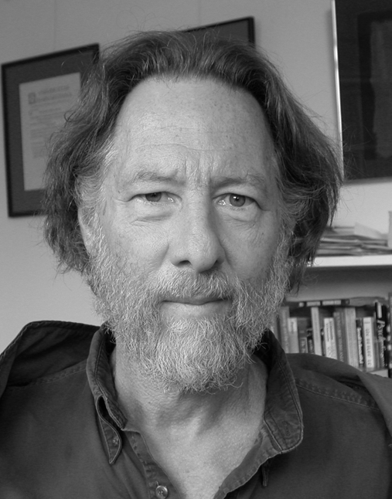
Richard Solomon Distinguished Lecture

William M. Baum, University of California, Davis
Rethinking Reinforcement: Allocation, Induction, and Correlation

The concept of reinforcement is at least incomplete and almost certainly incorrect. An alternative way of organizing our understanding of behavior utilizes three concepts: allocation, induction, and correlation. Allocation means choice: All behavior entails choice and consists of choice. Allocation changes as a result of induction and correlation.

Biography: William M. Baum received his A.B. in psychology from Harvard College in 1961. Originally a biology major, he switched into psychology after taking courses from B. F. Skinner and R. J. Herrnstein in his freshman and sophomore years. He returned to Harvard University for graduate study in 1962, where he was supervised by Herrnstein and received his Ph.D. in 1966. He spent the year 1965-66 at Cambridge University, studying ethology at the Sub-Department of Animal Behavior. From 1966 to 1975, he held appointments as post-doctoral fellow, research associate, and assistant professor at Harvard University. He spent two years at the NIH Laboratory for Brain, Evolution, and Behavior, and then accepted an appointment in psychology at University of New Hampshire in 1977. He retired from there in 1999. He currently has an appointment as Associate Researcher at University of California, Davis and lives in San Francisco. His research concerns choice, molar behavior-environment relations, foraging, and behaviorism. He is the author of a book, Understanding Behaviorism: Behavior, Culture, and Evolution.

Virginia Sexton Distinguished Lecture

Ethel Tobach, American Museum of Natural History
Contemporary Comparative Psychology Approach to Peace and War

When the world is suffering military mayhem everywhere, the application of comparative psychology, to the pacificity of human and nonhuman animals is challenging, but worthwhile. One response to the existence of wars is that wars are inevitable; we are destined to have wars because we are descended from animals that fight their own kind to survive. I want to share with you the thought that the human animal can build peace, other animals seem to need fights to survive.

Biography: A former President of EPA, Ethel Tobach’s career as a psychologist has spanned more than half a century and her work as an activist for social justice dates to the 1930s. Her scientific contributions are diverse, with important work being done in genetics and comparative psychology, as well as in feminist psychology.


EPA Historian’s Address

Wade E. Pickren, Ryerson University
Otto Klineberg: Between Anthropology and Psychology

Otto Klineberg (1899-1992), an EPA President, had a long and distinguished career in psychology. He earned his medical degree from McGill University (1925), then came to Columbia, where he earned his doctorate in psychology (1927). However, Klineberg might just have easily had an equally distinguished career in anthropology. His doctoral and immediate postdoctoral research was as much anthropology as psychology. The intersection and divergence of psychology and anthropology in this era are explored through the work of Klineberg.

Biography: Wade Pickren is Associate Chair of the Department of Psychology at Ryerson University in Toronto, Ontario and the Historian for the American Psychological Association. Wade was Historian and Director of the APA Archives and Library from 1998-2006. His historical work for the association included the conduct of the Past Presidents Oral History Program, two volumes that documented the importance of the NIMH and the VA on the growth of psychological science and practice in the post-war period, and documenting the impact of efforts to make psychology more inclusive of racial and ethnic minorities. His research program at Ryerson University examines human experience at the intersections of culture, history, and identity. Current projects include work on social justice and psychology in New York City since WWII, the impact of African Americans in psychology, and immigrant narratives of cultural strengths. Wade is President-elect of the Society for the History of Psychology, Incoming Editor of History of Psychology, and a Fellow of the American Psychological Association and the Society for the Psychological Study of Social Issues.

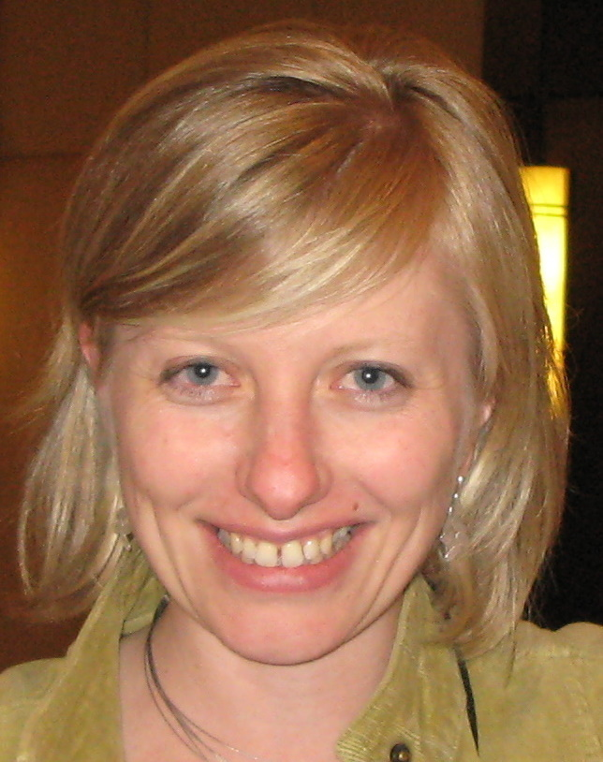
G. Stanley Hall Lecture Series

Alexandra Rutherford, York University
Culture and Controversy: Situating B. F. Skinner in Psychology’s History

B. F. Skinner (1904-1990) is one of the most celebrated – and maligned – figures of 20th century psychology. To fully evaluate his significance in psychology's history, it is necessary to move beyond internalist accounts that focus on the truth or error of his position, and place his contributions in their broader social, political, and professional contexts. What role did Skinner's ideas play in shaping post-WWII American life? How was the application of Skinnerian principles to everyday problems received by the American public, including patients, prisoners, and policy-makers? What can this analysis tell us about the relationship between psychology and its publics? This talk will situate Skinner and his work in mid-20th century American life as an example of such a contextual analysis. The benefits of this approach to teaching and writing psychology’s history will be highlighted.

Biography: Alexandra Rutherford is an associate professor of psychology at York University in Toronto. She is a faculty member in the History and Theory of Psychology Graduate Program, where she teaches and works with students who are interested in a wide variety of historical and theoretical issues in psychology. She has recently published Beyond the Box: B. F. Skinner’s Technology of Behavior from Laboratory to Life, 1950s-1970s (Toronto: University of Toronto Press, 2009), in which she offers the first full-scale historical account of how, when, and where Skinner’s followers exported his behavior-change techniques from the animal laboratory into everyday life, and how post-WWII Americans both embraced and resisted these efforts. She is a fellow of three APA Divisions and serves on the Executive Committees of Divisions 1, 9, and 35. She is currently working on a new project on the history of the relationship between feminism and American psychology from the late 1800s through the second wave of the women’s movement. She is the co-author, with Wade Pickren, of a forthcoming textbook on the history of psychology, A History of Modern Psychology in Context (New York: Wiley), that will appear in February, 2010.

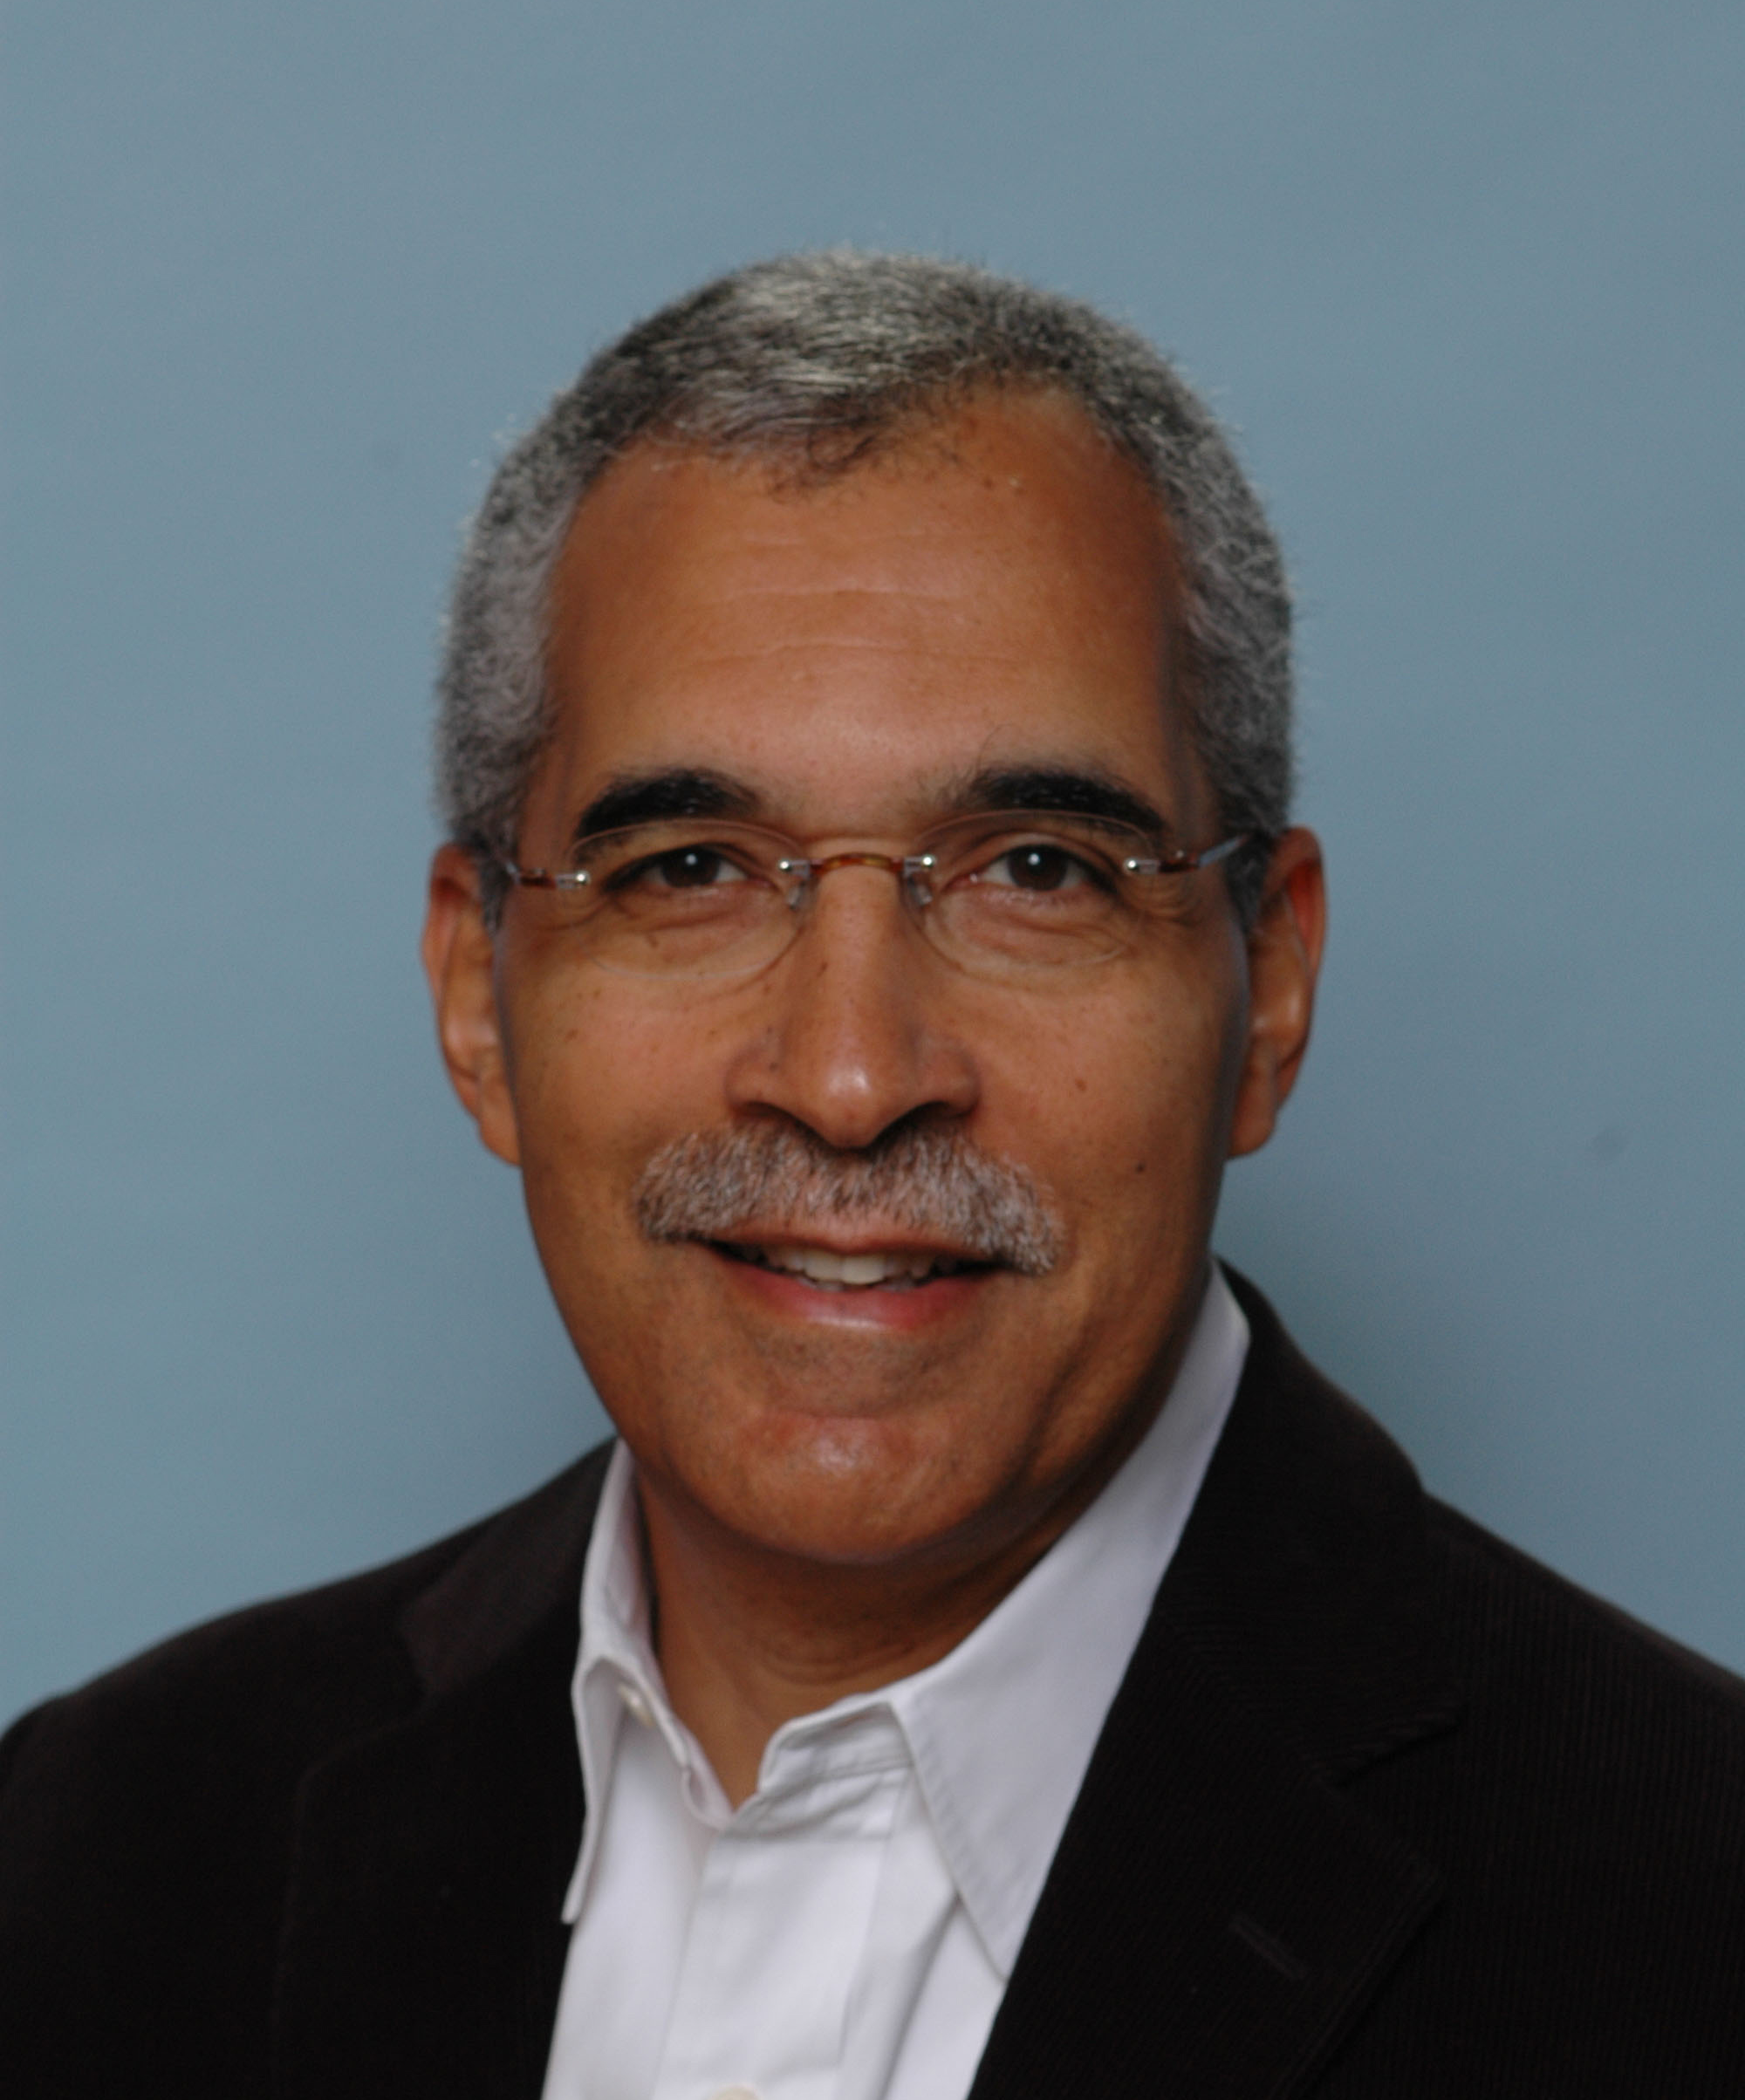
APS William James Distinguished Lecture

Claude M. Steele (Provost, Columbia University)
Whistling Vivaldi: And Other Clues to How Stereotypes Affect Us

Biography: Claude M. Steele is the twenty-first Provost of Columbia University, as well as a Professor of Psychology. A leader in the field of social psychology, Steele’s research focuses on the psychological experience of the individual and, particularly, on the experience of threats to the self and the consequences of those threats. His early work considered the self-image threat, self-affirmation and its role in self-regulation, the academic under-achievement of minority students, and the role of alcohol and drug use in self-regulation processes and social behavior. While at Stanford University, he further developed the theory of stereotype threat, designating a common process through which people from different groups, being threatened by different stereotypes, can have quite different experiences in the same situation. The theory has also been used to understand group differences in performance ranging from the intellectual to the athletic. A past Board Member of the Association for Psychological Science (APS) and an APS William James Fellow, Steele has been elected to the National Academy of Sciences, the National Academy of Education, the American Academy of Arts and Sciences, and to the American Philosophical Society. He is a member of the Board of the Social Science Research Council and of the John D. and Catherine T. MacArthur Foundation Board of Directors. Steele is a prolific author with numerous articles in leading scholarly journals in psychology. A book entitled Whistling Vivaldi: And Other Clues to How Stereotypes Affect Us is forthcoming.


Behavioral Neuroscience: Keynote Speaker

Tracey Shors, Rutgers University
Saving your brain: How learning keeps new neurons alive

The brain produces new neurons throughout life, especially in the hippocampus, a brain region involved in many processes of learning. However, most of these new cells die unless the animal learns something new and challenging. Thus, effortful learning persistently alters the structure and circuitry of the adult brain. With this lecture, I will address how learning interacts with neurogenesis to keep the brain fit for learning.

Biography: Dr. Shors received her Ph.D. in 1986 from the University of Southern California, after which she studied for several years as a postdoctoral associate of Dr. Richard Thompson. She then joined the faculty of Princeton University, and in 1999 moved to Rutgers, where she is now a Professor of Psychology. Dr. Shors' publications in Science, Nature, Nature Neuroscience and Scientific American have illuminated our understanding of stress responses, sex differences, and the role of neurogenesis in learning and memory. Dr. Shors' work has been funded by NASA, NSF, NIMH, the Whitehall Foundation, and the National Alliance for Research on Schizophrenia and Depression.

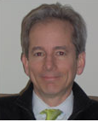
Clinical Psychology: Keynote Speaker

Jeffrey J. Magnavita, Private Practice
Toward Unified Clinical Science: A Psychotherapist's Perspective

There is an emergent movement toward unifying clinical science. The practice of psychotherapy is a convergent point of interest for clinical scientist, practitioners, theorists, basic researchers as well as many related disciplines. This address will examine the trend toward unification through the lens of a psychotherapist by looking at psychotherapy in the 20th century, how it evolved and where it is headed in the 21st century.

Biography: Jeffrey J. Magnavita, PhD, ABPP, FAPA, is a diplomate of the American Board of Professional Psychology and fellow of the American Psychological Association (APA). He received the 2006 Award for Distinguished Professional Contribution to Independent Practice in the Private Sector from APA for his work in unifying psychotherapy and personality systematics. He will be president of Division 29 (Psychotherapy) for 2010 and is the author of numerous books including Personality-Guided Relational Psychotherapy: A Unified Approach.


Clinical Psychology: Invited Speaker

Robin Cautin, Manhattanville College
The Road to Boulder: David Shakow, Worcester State Hospital, and the Scientist-Practitioner Model

The field of clinical psychology would change dramatically following WWII, owing to factors both internal and external to psychology, and to particular individuals devoted to its professionalization. David Shakow (1901 -1981), Chief Psychologist and Director of Psychological Research at Worcester State Hospital (WSH), 1928 – 1946, dramatically influenced the course of the field with his conception of the clinical psychologist. His ideas would form the framework of the Scientist-Practitioner Model of training.

Biography: Robin L. Cautin, Ph.D. is Associate Professor and Chair of the Psychology Department at Manhattanville College in Purchase, New York. Dr. Cautin earned her Ph.D. in clinical psychology from Case Western Reserve University in 1999. A significant portion of her historical work focuses on the life and work of David Shakow. In 2008 she was the recipient of the Early Career Award for APA’s Division 26 (History of Psychology).


Clinical Psychology: Invited Speaker

Fredrick J. Wertz, Fordham University
Qualitative Research in Psychology: History, Methodologies, and Applications

An historical sketch touches on the pioneering work of Wundt, Freud, James, Piaget, Maslow, and Kohlberg; Allport’s call for methodological rigor; the formalization of methodologies by Flanagan, Giorgi, Glaser and Stauss, Potter, and Bruner; the contemporary rise and development of qualitative methods across the subfields of psychology. Common procedures and methodological norms for the phases of research are spelled out. Applications to theoretical and practical problems are exemplified in areas of clinical and counseling psychology.

Biography: Frederick J. Wertz, Duquesne University PhD, chaired the Psychology Department, received the Distinguished Teaching Award in the Sciences, and serves on the IRB at Fordham University. Scholarship concerns the philosophy, methodology, theory, and cultural context of psychology. Editor of the Journal of Phenomenological Psychology, past president of APA’s Societies for Theoretical and Philosophical Psychology and Humanistic Psychology, he also edited The Humanistic Movement: Recovering the Person in Psychology and co-edited Advances in Qualitative Research in Psychology.


Cognitive Psychology: Keynote Speaker

Barbara Tversky, Columbia Teachers College
Spaces of Thought
Spatial knowledge derives from many sense modalities, is essential for survival, and is a basis for other knowledge. Our conceptions of space derive from our perceptions of space and our behavior in space. Both our bodies and the world have natural asymmetries that affect perception of and behavior in these spaces, yielding mental or external representations of them that systematically differ from space as measured by geographers or physicists. Perception and behavior are different for the different spaces we inhabit: the space of our bodies, the space immediately surrounding us, the space we navigate, and the space of graphics, the spaces we create to expand the mind and to communicate with others.

Biography: Barbara Tversky is Professor of Psychology at Columbia Teachers College and Professor Emerita of Psychology at Stanford University. She studied cognitive psychology at University of Michigan and taught several years at Hebrew University before moving to Stanford. Her research spans memory, categorization, spatial thinking and language, event perception and cognition, visual communication, design, HCI, and diagrammatic reasoning. She has enjoyed collaborations with computer scientists, linguists, philosophers, architects, poets, geographers, biologists, and chemists, among others.


Developmental Psychology: Invited Address

Stella F. Lourenco, Emory University
Using Generalized Magnitude to Organize the World (in the Mind)

In this talk, I will start by presenting behavioral and neural evidence in support of a system of generalized magnitude reasoning, one in which numerical, spatial, and temporal cues are conceptually intertwined and processed abstractly in a common representational code. Drawing on different paradigms, I will then argue that this general magnitude system is operational from early in human life and that it affects children’s expectations about how objects and events should be structured. I will conclude by presenting recent data from my lab which speaks to the extent of generalization. In this research, we show that (at least in adults) generalized magnitude reasoning extends to the processing of non-prototypical sources of magnitude information such as emotional expression.

Biography: Stella F. Lourenco is an Assistant Professor in the Psychology Department at Emory University, where she has been since January 2007. Dr. Lourenco’s research has focused on the development of spatial and numerical reasoning, with particular attention paid to the conceptual associations between space and number. Her research has also highlighted individual differences in the representation of spatial information, emphasizing how the body affects location processing. Dr. Lourenco’s work is federally funded by the National Institute of Child Health and Human Development (NICHD). She is also the author of numerous scholarly journal articles and a member of several research organizations, including the Society for Research in Child Development (SRCD), the Association for Psychological Science (APS), and the Cognitive Neuroscience Society (CNS).

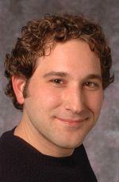
Developmental Psychology: Invited Address

Sean Duffy, Rutgers University
Encoding Spatial Extent in Early Childhood: Universal Processes and Cultural Differences

The ability to encode the amount or extent of a continuous quantity is a quantitative skill employed in a variety of everyday tasks. In this talk, I will review several studies on how infants and young children encode continuous quantities. Taken together, these studies suggest that an early capacity to encode relative extent may be important starting point for the later ability to represent absolute extent and indicate that universal and cultural processes play a significant role in shaping spatial skills in young children.

Biography: Sean Duffy received his Ph.D. in developmental psychology from the University of Chicago in 2003. He was a postdoctoral fellow at the Institute for Social Research Center for Group Dynamics (working with Shinobu Kitayama) and was associated with the LIFE program at the Max Planck Institute for Human Development in Berlin, Germany. During this period, Duffy conducted research at Kyoto University in Japan on projects related to cultural psychology. In 2005, Duffy moved to Rutgers University in Camden, NJ, where he is an assistant professor of psychology. Duffy conducts interdisciplinary research on a variety of topics, ranging from the development of spatial reasoning in early childhood, cultural differences in cognitive processes in children and adults, cognitive processes related to estimation and verbal comprehension, and on issues related to environmental psychology.


History of Psychology: Invited Address

Suzanne Ouellette, CUNY Graduate Center

Robert W. White and Current Psychological Practice

White understood lives as lived amidst social, political, and cultural forces. He called for persons to be studied “the long way” by investigators who appreciate inevitable change, and use tools drawn from history, the arts, and humanities. This paper creates a scholarly space in which White’s too often overlooked relevance is recognized, particularly in light of the academy’s increasing acceptance of contextual approaches, intensive and extensive case studies, narrative research, and the role of self-reflexivity.

Biography: Suzanne C. Ouellette is Professor in the Social/Personality and Developmental Psychology programs, and Coordinator of the Interdisciplinary Concentration in Health and Society. Current research projects include biographical and historical work on the study of lives in psychology, a collaboration with a landscape architect on the psychology of gardens, gardening, and gardeners; and a study of self and identity processes and their relevance for the health of gay men and lesbian women.


History of Psychology: Invited Address

Christopher Green, York University
140 Years of Psychology Trying to Capitalize on Evolutionary Theory

It is often argued that evolutionary theory was effectively banished from psychological thought during the 20th century. This paper examines the early history of American psychology in order to demonstrate that, far from being unwilling to incorporate Darwinian insights, many of the most significant early American psychologists attempted to found scientific psychology on an explicitly evolutionary basis, and that their influence can be felt right through the behaviorist era on up to the present day.

Biography: Christopher D. Green is a professor in the History & Theory of Psychology graduate program at York University (Toronto), and past president of the Society for the History of Psychology (APA, Div 26). His recent publications include "Darwinian theory, functionalism, and the first American psychological revolution" (American Psychologist, 2009) and the book Psychology Gets Into the Game: Sport, Mind, and Behavior, 1880-1960 (co-edited with L. T. Benjamin, 2009).

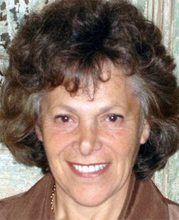
Social Psychology: Keynote Speaker

Ellen Langer, Harvard University
Counterclockwise: Mindful Health and the Power of Possibility

Knowing what is and knowing what can be are not the same thing. The
studies that will be described show us how simply using a different
word, offering a small choice, or making a subtle change in our physical
environment can improve our vision, old age, cancer, weight, and heart
health—as well as for our fundamental happiness. Many seemingly
unavoidable damages to our body can be reversed or ameliorated by the
conscious application of the mind.
Biography: Ellen Langer, Yale PhD, Harvard Professor of Psychology, artist, recipient of a Guggenheim Fellowship and three Distinguished Scientist Awards has authored eleven books and over 200 research articles on the illusion of control, successful aging, decision-making, to name a few of the topics. Her best selling books include Mindfulness; The Power of Mindful Learning; On Becoming an Artist: Reinventing Yourself Through Mindful Creativity; and her most recent book, Counterclockwise: Mindful Health and the Power of Possibility. Visit her website, www.ellenlanger.com for more information and to read the first chapter of her new book.

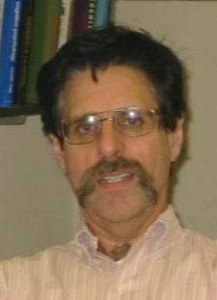
Teaching of Psychology: Keynote Speaker

Arnold Glass, Rutgers University
How to Teach Almost Everyone Almost Everything: Distributed Testing Increases Learning and Long-term Retention in a Large College Lecture Course

Modern technology has made it possible to turn instruction in a large college lecture course into an active experience for the student by presenting questions both online before and after class and in class throughout the lecture. Students respond in class using personal response devices (clickers) and receive immediate feedback. The primary function of the questions is not evaluation (though they also serve this function) but instruction. Responding to a question is a voluntary action, consequently it increases long-term retention over merely hearing the answer to the question. When students answer related questions, one or two days before, in, and a week after class, they answer over 80% of the questions on block exams containing novel but related questions correctly and over 90% of the questions on the final exam correctly.

Biography: Arnold Glass attended public school in Irvington New Jersey and in New York City. He received his BA in psychology from the University of Buffalo and his PhD in Psychology from Stanford University. He was a Fulbright Scholar at the University of Oslo, Norway. He has written a textbook on human cognition and has taught college courses of various sizes for over 30 years. His current research includes embedding experiments on learning and memory within the structure of multi-section lecture courses, so that the experimental findings are immediately applicable to instruction.

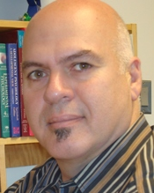
Teaching of Psychology: Invited Address

Miguel Roig, St. John’s University
Dealing with a Persistent Pandemic: Detecting and Preventing Student Plagiarism

In spite of the availability of tools designed to detect and prevent student plagiarism, this type of misconduct continues to occur unabated. Part of the problem is that many instances of plagiarism do not conform to the simple act of copy-pasting from sources without attribution. Moreover, some of these subtler forms of plagiarism are seldom discussed in student handbooks, syllabi, or course hand-outs. To complicate matters, instructors across the various disciplines are not always in agreement as to what types of infractions constitute plagiarism. Thus, the burden of preventing, detecting, and even of defining this type of misconduct, falls squarely on the shoulders of the individual instructor. I will address these issues by discussing the use of available tools for detecting student copying. I will also outline a number of strategies that instructors can use to prevent blatant, as well as the more subtle forms of this student malpractice.

Biography: Dr. Roig was born in La Habana, Cuba. He and his parents emigrated to the United States in 1970 and settled in New Jersey. After learning English in ESL, Dr. Roig attended Jersey City State College, where he initially majored in philosophy. During the fall semester of his sophomore year, he took Experimental Psychology from Curt Thomsen and changed to a major in psychology, planning to pursue a career in research. He entered the Master of Arts program in General Experimental Psychology at St. John's University in Queens and after completing that degree was accepted in the doctoral program at the Institute for Cognitive Studies of Rutgers University’s Newark campus (NJ). His first full-time position was with the New York City Department of Personnel where he was a Tests and Measurement Specialist. In 1987, he left the NY City Dept. of Personnel and accepted his first full-time teaching position at Wagner College. Two years later, he re-joined the St. John's family in their Staten Island campus.

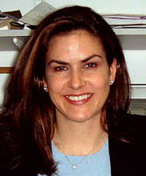
Psi Chi: Distinguished Lecturer

Elizabeth Phelps, New York University
Changing Fear
In this talk, I will explore how animal models of fear learning extend to humans in a social context. Specifically, I will demonstrate how the neural circuitry of fear conditioning forms the basis to fears learned through social communication and how changing fears in humans through social and non-social means relies on overlapping neural mechanisms. Finally, I will discuss novel techniques to eliminate fears in humans by targeting reconsolidation.

Biography: Elizabeth A. Phelps received her PhD from Princeton University in 1989, served on the faculty of Yale University until 1999, and is currently the Silver Professor of Psychology and Neural Science at New York University. Her laboratory has earned widespread acclaim for its groundbreaking research on how the human brain processes emotion, particularly as it relates to learning, memory and decision-making. Dr. Phelps is the recipient of the 21st Century Scientist Award from the James S. McDonnell Foundation and a fellow of the American Association for the Advancement of Science and the Society for Experimental Psychology. She has served on the Board of Directors of the Association for Psychological Science and the Society for Neuroethics, was the President of the Society for Neuroeconomics and is the current editor of the APA journal Emotion.


Psi Beta: Invited Address
Co-Sponsored By Psi Beta and Worth Publishing
Robin Rosenberg, Private Practice
Life Lessons That Superheroes Teach Us
Superheroes can provide a roadmap for handling the vicissitudes of life. Superheroes teach us that it is important to identify and harness the way in which each person is different-- the unique constellation of talents and abilities. Superheroes also model one way that we can overcome adversity. Psychologist Robin S. Rosenberg discusses relevant psychological research about these life lessons, and illustrates them with examples from superhero comics, television shows, and movies.

Biography: Robin S. Rosenberg is a clinical psychologist in private practice and has taught psychology at Lesley University and Harvard University. She has been certified in clinical hypnosis and is a member of the Academy for Eating Disorders. She received her B.A. in psychology from New York University, and her M.A. and Ph.D. in clinical psychology from the University of Maryland, College Park. Dr. Rosenberg did her clinical internship at Massachusetts Mental Health Center, had a postdoctoral fellowship at Harvard Community Health Plan, and was on the staff at Newton-Wellesley Hospital's Outpatient Services. Dr. Rosenberg specializes in treating people with eating disorders, depression, and anxiety.

Psi Beta: Invited Address

Janell L. Carroll, University of Hartford
Sex Around the World

Dr. Carroll will explore sexuality around the world, taking a look at how sexual attitudes and behaviors vary by culture. Using videos from her sexuality research around the world, Dr. Carroll will explore the role of culture in the expression of human sexuality.

Biography: Dr. Janell Carroll received her Ph.D. in human sexuality education from the University of Pennsylvania in 1989. She teaches in the psychology department at the University of Hartford, in Connecticut, is an AASECT-certified sexuality education, and has received numerous awards for her teaching and work in the field of human sexuality. In 2005, she received the Gordon Clark Ramsey Award for Creative Excellence from the University of Hartford, given to professors who demonstrate sustained excellence and creativity in the classroom. Dr. Carroll has also been recognized by Planned Parenthood as a Sexuality Educator of the Year. Dr. Carroll is author of the college textbook, Sexuality Now: Embracing Diversity. A dynamic educator, speaker, and author, Dr. Carroll has hosted two of her own radio talk shows about sexuality and appeared as an expert on numerous television talk shows and networks. She maintains her own sexuality website. http://www.drjanellcarroll.com

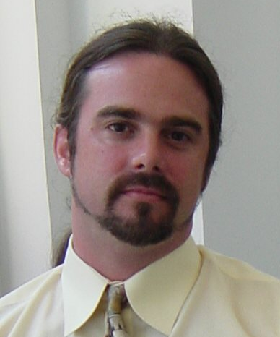
Society for Community Research and Action: Invited Address
John Draper, National Suicide Prevention Lifeline
Community-wide crisis prevention and intervention: The unique role of crisis call centers

This presentation will focus on how crisis call centers and the national Lifeline network of centers uniquely approach community-wide crisis work. It will review: a brief history of crisis hotlines; the mission, structure and work of the SAMHSA-funded National Suicide Prevention Lifeline; groundbreaking research findings on crisis hotlines; how crisis lines promote access and continuity of care in fragmented behavioral health care systems; and advances and future implications of crisis line work in the U.S.

Biography: Dr. Draper holds a doctoral degree in Counseling Psychology (University of Missouri-Columbia). He is the Director of the National Suicide Prevention Lifeline Network, administered by Link2Health Solutions, a subsidiary of the Mental Health Association of New York City. Since September 2004, Dr. Draper has overseen all aspects of this service that connects 1-800-273-TALK callers to the nearest crisis center within a national network of more than 140 centers. He also has a private practice.
President’s Integrative Symposium – PLENERY SESSION
Supported by the American Psychological Association
Chair/ Discussant: Kurt Salzinger, Hofstra University

Connections to Other Sciences Symposium
Like other sciences, psychology has become increasingly specialized, as an old wag once said, we are learning more and more about less and less so that eventually we will know everything about nothing. The object of this symposium is to show another trend. Three pioneers in making connections between psychology and mathematics, biology and economics will show us how we can learn more by expanding our focus.

Participants:


Linda Bartoshuk, University of Florida
Psychology and biology: tongue anatomy predicts taste intensity- a Rosetta Stone for psychophysical scaling?

Biography: Linda Bartoshuk, Bushnell Professor at the University of Florida, is Director of Human Research for the UF Center for Smell and Taste. She is currently president of the Association for Psychological Science, past-president of EPA, Divisions 1 and 6 of the American Psychological Association and the Association for Chemoreception Sciences. She has been elected to the Society of Experimental Psychologists, American Academy of Arts and Sciences and the National Academy of Sciences.


Daniel Kahneman, Princeton University
Psychology and Economics

Biography: Daniel Kahneman is Professor Emeritus and Research Scholar at the Woodrow Wilson School of Public Affairs at Princeton. In recent decades he has studies judgment, decision making and well-being. He is the recipient of numerous honors, including the Outstanding Lifetime Contributions to Psychology Award from the APA (2007), the Nobel Prize for Economics (2002) and, together with Amos Tversky, the Distinguished Scientific Contribution Award of the APA (1983) and the Grawemeier Award for Psychology (2002).

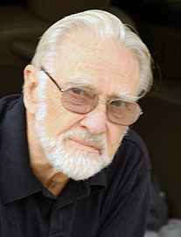
Duncan Luce, University of California, Irvine
"Opening" the Black Box versus Behavioral Invariances

Biography: Robert Duncan Luce is the Founding Director of the Institute for Mathematical Behavioral Sciences, Distinguished Research Professor of Cognitive Sciences, and Research Professor of Economics at the UC Irvine. His research areas include measurement theory, measurement, game theory, audition, psychophysics, decision theory, and response times. In 1972 he was elected to the National Academy of Sciences for his work on fundamental measurement, utility theory, global psychophysics, and mathematical behavioral sciences. He received the 2003 National Medal of Science in behavioral and social science for his contributions to the field of mathematical psychology.

Presidents Invited Symposium

Chair/ Discussant: Kurt Salzinger, Hofstra University

Will the real behavior therapy please stand up?
When behavior therapy first came to be, other therapists tried hard to distinguish their form of therapy from it but as time wore on, variations of behavior therapy came to be and even those forms of therapy that had eschewed the word "behavior" now adopted it with enthusiam. The object of this symposium is to identify which form of therapy is now the authentic, or if not he authentic, then the most effective form of behavior therapy.

Participants:


Stefan Hofmann, Boston University
Cognitive Therapy

Biography: Stefan G. Hofmann, Ph.D. is Professor of Psychology at the Department of Psychology at Boston University where he directs the Psychotherapy and Emotion Research Laboratory. His main research focuses on the mechanism of treatment change, translating discoveries from neuroscience into clinical applications, emotion regulation strategies, and cultural expressions of psychopathology, such as social anxiety disorder.

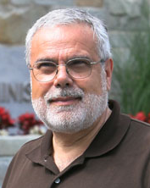
Ray DiGiuseppe, St. John’s University
Rational Emotive Behavior Therapy

Biography: After earning a B.S. degree from Villanova University (1971), Dr. DiGiuseppe received his Ph.D. from Hofstra University in 1975; and completed a postdoctoral fellowship at the Albert Ellis Institute in 1977. Dr. DiGiuseppe joined St. John's in 1987, where he is professorand department chairperson. Since 1980, Dr. DiGiuseppe has served as Director of Education of the Albert Ellis institute. He received the Jack Krasner early career contribution award from APA's Division of Psychotherapy (29) and has served as President of the Association for Behavioral and Cognitive Therapy.


James Herbert, Drexel University
Acceptance and Commitment Therapy

Biography: James D. Herbert, is Professor of Psychology at Drexel University, where he directs the Anxiety Treatment and Research Program, and serves as Associate Dean in the College of Arts and Sciences. Dr. Herbert’s research focuses on acceptance-based behavior therapy, the psychopathology of anxiety disorders, remote internet-based clinical services, and the promotion of evidence-based practice in mental health. He is Associate Editor of the Scientific Review of Mental Health Practice and a Fellow of the Institute for Science in Medicine, the Commission for Scientific Medicine and Mental Health, and the Academy of
Cognitive Therapy.

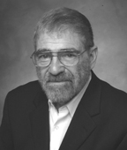
Robert J. Kohlenberg, University of Washington
Functional Analytic Psychotherapy

Biography: Bob Kohlenberg is a professor at the University of Washington, is certified by the American Board of Professional Psychology, and received the Washington State Psychological Association’s Distinguished Psychologist Award. He is the co-creator of Functional Analytic Psychotherapy (FAP), a behavior analytic approach to understanding the mechanism of action that operates in curative therapist-client relationships. He has published papers on using FAP for a wide range of disorders as well as basis for psychotherapy integration.

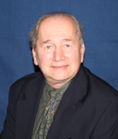
Richard M. O'Brien, Hofstra Univerisy
Classical Behavior Therapy

Biography: Dr. O'Brien is Professor of Psychology and a Core Faculty Member in the Ph.D. Program in Clinical Psychology. Dr. O'Brien specializes in applied behavior analysis in industry and sports. He maintains a consulting practice in those areas, as well as a private practice in behavioral approaches to clinical problems. He has numerous research publications in his specialty areas as well as a co-authored book on golf and an edited handbook on organizational behavior management. He is also an Associate Editor of the Journal of Organizational Behavior Management. Dr. O'Brien's research avocation has been in the area of hypnosis.

Cognitive Psychology: Invited Symposium

Chair/ Discussant: Todd Gureckis, New York University

Agenic Learning: Integrating Developmental, Educational, and Computational Perspectives Symposium
Psychologists and educators have long recognized that human learning is, at least in part, an active process involving the search and selection of new information that enriches our understanding of the world. This view raises important issues that are often overlooked in human studies which emphasize passive or observational learning. In particular, how do people decide what information they should seek from their environment at any point in time? What is the difference between evidence acquired by one’s own actions versus those obtained by observing someone else? What impact does the data selection process have on the types of inferences children and adults make about the world? To what degree can people leverage their meta-cognition about what they currently know to enhance their learning? Recently, there has been a renewed interest in these issues from a number of diverse literatures including work in education, developmental psychology, computational modeling, and behavioral studies. The goal of this symposium is to bring together researchers working in these disparate areas to better understand the circumstances under which active, self-directed learning can be an effective learning tool, how people select what information they want to learn about, the impact this has on concept learning and reasoning, and how these abilities may change throughout development.

Participants:

Todd Gureckis & Doug Markant, New York University
Modeling the Psychological Process of Search and Discovery
Tamar Kushnir, Cornell University
Agency and Probability in Preschoolers' Causal Inferences
Marjorie Rhodes, New York University
Children’s Evaluation of Evidence During Inductive Learning Tasks
Lisa K. Son, Barnard College, and Pantelis P. Analytis, Institute Jean Nicod
The Value of Choice
Cognitive Psychology: Invited Symposium

Chair/ Discussant: Bob Rehder, New York University

Modern causal reasoning: Intentionality, Morality, and Normality
This symposium presents new research demonstrating how causal knowledge supports not just simple inferences among causes and effects but also how it influences a wide variety of everyday judgments and decisions. Speakers consider the role of causality in moral reasoning, judgments of intentionality, acts of categorization, and people's conception of what makes one's behavior "normal."

Nancy S. Kim, Northeastern University
Causal Explanations and Judgments of Psychological Normality
Steven A. Sloman, Scott Ewing, & Philip Fernbach, Brown University
A Causal Model of Intentionality Judgment

Bob Rehder & ShinWoo Kim, New York University
A Generative Model of Conceptual Representation

Michael R. Waldmann & Alex Wiegmann, University of Göttingen, Germany.
A Causal Contrast Theory of Moral Intuitions

Cognitive Psychology: Invited Symposium

Chair: William Hirst, New School for Social Research

Social Influences on Memory
Although psychologists have long recognized the social nature of memory, they have generally sought to uncover underlying context-free general principles. There is a growing awareness, however, that one cannot fully understand how people memorize and remember without exploring social influences. Four empirical papers are presented that investigate social aspects of memory. They focus on the effects of collaborative encoding and the mnemonic influence of selective remembering on speaker and listener. Introductory and concluding remarks will put these empirical results into a larger context.

William Hirst, New School for Social Research
Introductory Remarks

Sarah J. Barber, Suparna Rajaram, Art Aron, & Ethan Fox, Stony Brook University
When two heads are not better than one: The negative effects of collaboration during learning

Adam Congleton & Suparna Rajaram, Stony Brook University
The Influence of Learning History on Collaborative and Individual Recall

Alin Coman, Charles Stone, Caitlin Thompson, Emanuele Castano, & William Hirst, New School for Social Research
Mnemonic consequences of dehumanizing the out-group

Jonathan Koppel, Zachariah Sky, Robert Meksin, & William Hirst,
New School for Social Research
The Role of Expertise in Social Contagion and Socially-Shared Retrieval-Induced Forgetting: An Application to Educational Texts

Discussant: Suparna Rajaram, Stony Brook University

Developmental Psychology: Invited Symposium

Chair/Discussant: Rachel Barr, Georgetown University

Learning from Media during Childhood
Transfer of learning from media including books and television is challenging during early childhood. Previous studies have focused only on the amount of early television and book exposure but not on how and in what context young children’s learning occurs. Today’s symposium will take a multi-disciplinary approach to examine young children’s media experiences and the challenge of learning from books and television. The symposium will highlight the importance of looking across context and taking a multi-method approach. The papers will also focus on the complexity of the early learning environment and how learning is influenced by books and television. The first speaker Deborah Linebarger will discuss findings from a large nationally representative survey study that shows connections between media content and executive functioning skills. The second speaker Alan Mendelsohn will describe an early intervention project with low income Latino families where he investigates early media use and parent-child interaction patterns. The final two speakers will discuss experimental studies that directly examine how young children learn from television and books. Sarah Roseberry will focus on the challenges of word learning from television and Patricia Ganea will similarly focus on the challenges of word learning from books. These findings highlight that learning from books and television provide unique cognitive challenges to young children.

Deborah Linebarger, Matt Lapierre, Sarah Vaala, Jessica Taylor Piotrowski, & Rachel Barr, University of Pennsylvania and Georgetown University
The implications of repeated exposure to background television on young children’s executive functioning skills: Results from a national parent survey

Alan L. Mendelsohn, Benard P. Dreyer, Suzy Tomopoulos, Carolyn Brockmeyer, & Samantha Berkule-Silberman, Department of Pediatrics, New York University School of Medicine
The Video Interaction Project: Promotion of Responsive Parenting through a Pediatric Primary Health Care Preventive Intervention

Sarah Roseberry & Kathy Hirsh-Pasek, Temple University
Honey, We Shrunk the Sesame Characters! Dual Representation Inhibits Children’s Language Learning From Video

Patricia A. Ganea, Boston University
Toddler’s learning and transfer of information from picture books

FEATURED SERIES on PSYCHOLOGY AND LAW
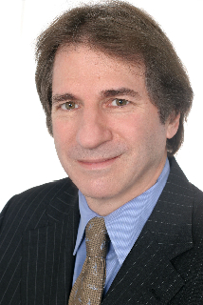
Psychology & Law: Keynote Speaker
Barry Scheck, Co-Director, The Innocence Project
Social Framework Analysis and Eyewitness Evidence: The Need for Reliable Expert Testimony
The Innocence Project assists police, prosecutors, and defense attorneys in trying to bring about reform in many areas of the criminal justice system, including eyewitness identification procedures, interrogation methods, crime laboratory administration, and forensic science research. In its seventeen years, 249 individuals have been exonerated in the United States through post-conviction DNA testing. You can read about these cases at www.innocenceproject.org.

Biography: Barry C. Scheck is Professor of Law at the Benjamin N. Cardozo School of Law. He received his undergraduate degree from Yale University (1971) and his law degree from Boalt Hall School of Law, UC - Berkeley (1974). Scheck and his colleague Peter Neufeld, Co-Founded and Co-Direct the Innocence Project, an independent nonprofit organization which uses DNA evidence to exonerate the wrongly convicted.

Psychology & Law: Invited Speakers - Law in the Community

Tom Tyler,New York University
Law and the Psychology of Regulation
Robin Steinberg, Executive Director, Bronx Legal Defenders
Holistic Lawyering

Psychology & Law: Invited Speakers - Neuroscience and Responsibility

Stephen J. Morse, University of Pennsylvania Law School & School of Medicine
Promises and Pitfalls of Neuroscience in the Law
Kevin Carlsmith, Colgate University
The Social Psychology of Punishment Motives: Perpetrator Agency, Retribution, and Incapacitation

Psychology & Law: Invited Speakers - On the Road to Convictions

Margaret Bull Kovera, John Jay College of Criminal Justice - CUNY
Biased Hypothesis Testing and Behavioral Confirmation in Jury Selection
Barbara A. Spellman, University of Virginia & University of Virginia School of Law
Credibility in the Courtroom
Judith Platania, Roger Williams University
Conceptualizing the Use and Efficacy of Legal Safeguards Against Prosecutorial Misconduct

Roundtable Discussion: How To Get Involved in Psychology & Law Research
Discussants from John Jay College of Criminal Justice, Roger Williams University, Colgate University, and the University of Virginia will describe their academic programs and answer questions about how students can get involved in psychology and law research.

Psychology & Law: Invited Speakers - Children and Adolescents in the Legal System

Angela M. Crossman, John Jay College of Criminal Justice - CUNY
The Development of Children’s Lie-Telling
Jessica Kostelnik, University of Virginia
Police and Community Perceptions of Maturity and Coercion in Interrogation
Preeti Chahuan, John Jay College of Criminal Justice - CUNY
Racial Differences in Substance Use among Juvenile Offenders

