Early Contributions to Psychology
Juan Luis Vives (1492- 1540)
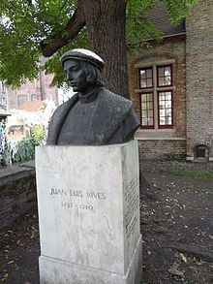
The history of contributions of Hispanics to the field of psychology often begins by highlighting the work of Juan Luis Vives (1492 -1540), a Spaniard born in Valencia.
Based on historical documents, Juan Luis Vives was a noted scholar of his time and was recognized for his work emphasizing empirical inductive methods. In addition, his work also addressed the recall of memories and the psychology of emotions, and he was known to be the first to apply psychology to education. ^{3,4}
Santiago Ramón y Cajal (1852- 1934)
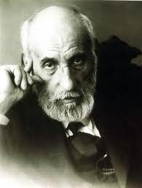

Santiago Ramón y Cajal, another notable Hispanic psychologist, was born in Petilla de Aragón, Spain. Ramón y Cajal was an accomplished researcher noted for his work on the nervous system.
In 1898 he was invited by G.Stanley Hall, then the president of Clark University, to give several lectures on his cutting-edge research on the cerebral cortex. In 1906 Ramón y Cajal (with Camillo Golgi) received the Nobel Prize for Physiology or Medicine for establishing the neuron as the basic unit of nervous structure.^{3, 5}
Jóse Ingenieros (1877- 1925)
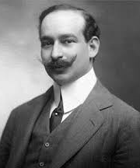
Jóse Ingenieros was an Argentine scholar who was initially trained in medicine and influenced Latin American psychology during the early years of the twentieth century. He is considered the first person to establish a comprehensive system of psychology in Latin America. In 1911 he published Psicología Genética (Biological Psychology), in which he “emphasized the unity of the biological and psychological worlds as two worlds of the same evolution…” (cited in Padilla, p.118). ^{3,6}

Contemporary Leaders in Psychology
George I. Sánchez (1906 -1972)
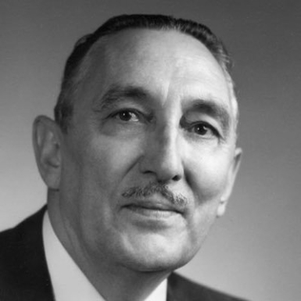
Jorge Isidoro Sánchez y Sánchez, known as George I. Sánchez, was born in New Mexico, received an Ed.D in educational administration from the University of California at Berkley, and spent most of his career at the University of Texas at Austin. Dr. Sánchez questioned the use of intelligence tests with Mexican American children and challenged the literature in psychology and education. Dr. Sánchez called for educational reform and was a pioneer in highlighting the need for educational systems to address the impact of poverty, cultural and linguistic differences, discrimination, and educational inequity on the academic achievement of Mexican American students. Dr. Sánchez has become known as the “father of Chicano psychology.” 3,8
John Garcia (1917-2012)
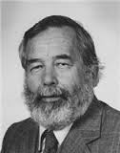
John Garcia was born in 1917 in Northern California to parents who immigrated from Mexico. In 1965 he received his master’s and doctoral degree from the University of California, Berkeley. During the 1950’s Garcia’s research with rats on conditioned taste aversion led to what has come to be called the Garcia effect. In 1978 Dr. John Garcia became the first Hispanic to be elected to the Society of Experimental Psychologists and the only Psychologist to be awarded the Howard Crosby Warren medal in the same year. Dr. Garcia was also concerned about the use of intelligence tests to predict the academic achievement of minority children. ^{3,7}
Carlos Albizu Miranda (1920-1984)
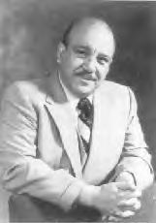
Carlos Albizu Miranda was born in Ponce, Puerto Rico in 1920. He completed his bachelor's degree in psychology at the University of Puerto Rico, a master's in experimental psychology, and a Ph.D. in clinical psychology from Purdue University. Upon completing his Ph.D., Dr. Albizu Miranda returned to Puerto Rico, where he quickly became a full professor at the University of Puerto Rico. Recognizing the need to address the unique challenges experienced by the population of Puerto Rico due to the marginalization experienced due to language, culture, and skin color, in 1966, Carlos Albizu founded the Instituto Psicologico de Puerto Rico. The institute's purpose was to provide culturally appropriate clinical training tailored to the needs of students and the population of Puerto Rico. In 1971, the institute became known as the Caribbean Center for Advanced Studies, with a corresponding branch called the Miami Institute of Psychology, opening in 1980. In 1980 Dr. Albizu Miranda was elected the first president of the National Hispanic Psychological Association and served from 1980 to 1982. Finally, on January 1, 2000, the institution's name in Puerto Rico and Miami was officially changed to the "Carlos Albizu University" by the Board of Trustees of the Caribbean Center for Advanced Studies. 8,9
Martha Bernal (1931–2001)
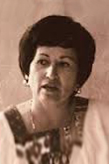
Martha Bernal was born in San Antonio, Texas. Her parents were Mexican immigrants. Martha received her master's degree from Syracuse University and, in 1965, received a Ph.D. in clinical psychology from the University of Indiana. Dr. Bernal was the first Latina to receive a Ph.D. in psychology from a United States university. Dr. Bernal's work contributed to using learning theory and methods to advance treatments and assessments for children with behavior problems. In addition, through her scholarship and professional engagement, she advocated for the advancement of multicultural psychology. Dr. Bernal contributed to establishing the American Psychological Association Board of Ethnic Minority Affairs (BEMA) and was a member of the Steering Committee Task Force, which led to the establishment of the National Latino/a Psychological Association, previously called the National Hispanic Psychological Association (NHPA). Dr. Bernal served as the second President of the Association. ^{8,9,10}

Patricia Arredondo
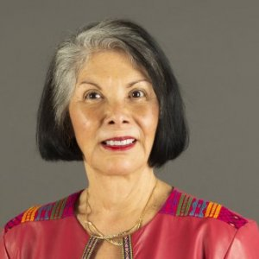
Patricia Arredondo was born in Lorain, Ohio, and obtained her master's degree in school counseling from Boston College and her Ph.D. in counseling psychology from Boston University in 1978. In 1979 Patricia Arredondo became an Assistant Professor at Boston University.
In 1985 Dr. Arredondo left academe to begin a career as the founder and President of Empowerment Workshops, Incorporated, where her work focused on workplace culture and diversity. In 1999 she returned to academe and held many leadership positions in the university. In 2013 Patricia Arredondo relocated to Chicago and accepted a position as President of the Chicago School of Professional Psychology. In addition to her leadership roles in the university, Dr. Arredondo was the founding President of the National Latina/o Psychological Association and the first Latina president of the American Counseling Association. In 2018, the American Psychological Association named her a Changemaker: Top 25 Women of Color Psychologists. ^{11,12}
Lillian Comas-Díaz
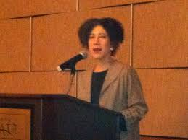
Lillian Comas-Díaz was born in Chicago and moved with her parents to Puerto Rico when she was six years old. She received her master's degree in Clinical Psychology from the University of Puerto Rico, and in 1979 she received her Ph.D. in Clinical Psychology from the University of Massachusetts. Dr. Comas-Díaz was a faculty member in the Psychiatry Department at Yale University, where she became the director of the Yale University Hispanic Clinic, and in 1986 she became a Clinical professor at the George Washington University Department of Psychiatry and Behavioral Sciences. In addition, she served as the director of the American Psychological Association Office of Ethnic Minority Affairs (APA-OEMA).
Moreover, Dr. Comas-Díaz was the founding Editor-In-Chief of Cultural Diversity and Ethnic Minority Psychology, the APA journal of Division-45. Dr. Comas-Díaz is also the co-founder of the Transcultural Mental Health Institute, and in 2019 she received the Gold Medal Award for Life Achievement in the Practice of Psychology. ^{7,13}
Melba J.T. Vasquez
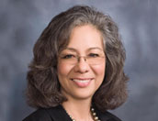
Melba J.T. Vazquez was born in Texas and is the oldest of seven children. Before becoming a psychologist, Dr. Vasquez received a bachelor's degree in English and Political science and certification in teaching. While teaching middle school, she completed her master's degree in Counseling Psychology at Texas State University in Austin, and in 1978 she completed her Ph.D. also, in Counseling from the University of Texas in Austin. Upon completing her doctorate, Dr. Vasquez worked in the University of Texas Austin's counseling center. Before moving into private practice, Dr. Vasquez taught at the University of Texas and Colorado State University. Dr. Vasquez served as President of the Texas Psychological Association, the Society of Counseling Psychology (APA Division 17), and the Society for the Psychology of Women (APA Division 35). In addition, she co-founded the Society for the Psychological Study of Ethnic Minority Issues (APA Division 45). In 2011 Dr. Melba Vasquez became the first Latina President of the American Psychological Association. ^{7, 14,15}
Anthony E. Puente
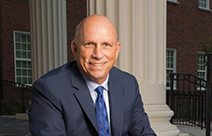
Anthony E. Puente was born in Cuba and emigrated to the US in 1960. He received his bachelor's degree from the University of Florida and his master's and doctoral degrees from the University of Georgia. Dr. Puente is currently a Professor of Psychology at the University of North Carolina Wilmington and maintains a private practice in clinical neuropsychology. Dr. Puente founded and edited the quarterly scientific journal Neuropsychology Review for ten years, the Journal of Interprofessional Healthcare, and a 33-book series in clinical neuropsychology. In addition, he has served as the Past-President of the Hispanic Neuropsychological Society, the National Academy of Neuropsychology, the North Carolina Psychological Association, the North Carolina Psychological Foundation, and the Division of Clinical Neuropsychology of the American Psychological Association. In 2017, Puente served as the 125th president of the American Psychological Association. Dr. Puente is currently the President-elect for the American Psychological Association Division of International Psychology.¹⁶

Joe L. Martinez
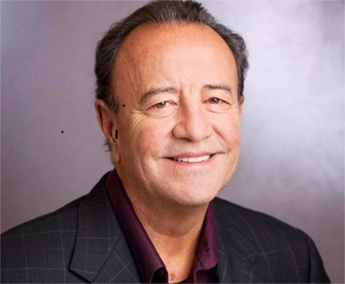

Joe L. Martinez was born in Albuquerque, New Mexico, on August 1, 1944 and died August 29, 2020. He received his B.A. from the University of California, San Diego; graduated with his M.S. in experimental psychology from New Mexico Highlands University in 1968; and earned his Ph.D. in physiological psychology in 1971 from the University of Delaware. He completed his postdoctoral training at the University of California, Irvine, and the Salk Institute in San Diego.
Martinez served as a professor in the Department of Psychology at the University of California, Berkeley, from 1982 to 1995. During this time he led an internationally recognized research laboratory and departed as professor emeritus.
In 1995 he joined UTSA as the Ewing Halsell Distinguished Chair in psychology. From 1995 to 2012 he was a beloved professor who founded and directed the Cajal Neuroscience Research Center, now known as the UTSA Neurosciences Institute. He oversaw the design and construction of the Biosciences Building, UTSA’s first research building. Each floor in the BSB contains tiles representing the neuroanatomical drawings of Santiago Ramon y Cajal.
During his tenure at UTSA, Martinez brought over $15 million in grant funding to the university.
In 2013 he moved to the University of Illinois at Chicago to become the chair of the department of psychology. He retired in 2016.
A passionate advocate for the advancement of underrepresented minorities in STEM, Martinez cofounded the Summer Program in Neuroscience, Ethics and Survival, a month-long course supported by the National Institutes of Health at the Marine Biological Laboratory in Woods Hole, Massachusetts.
For over 20 years he co-directed the American Psychological Association’s Diversity Program in Neuroscience, which supports the training of diverse doctoral and postdoctoral neuroscience students. He also led the APA’s efforts to develop a perpetual fund to provide permanent support for the training of diverse neuroscientists.
While at UTSA, Martinez mentored and graduated eight Ph.D. students—five of whom were members of the underrepresented minority community.
Martinez is known for his research on the modulation of learning and memory and the role of enkephalins in learning, memory and synaptic plasticity. He published approximately 200 research articles in peer-reviewed journals and edited the book Chicano Psychology and multiple editions of The Neurobiology of Learning and Memory.
He received many professional awards, including election as a fellow of the American Association for the Advancement of Science in 1995, the AAAS Mentor Award for Lifetime Achievement in 1994 and the Association for Neuroscience Departments and Programs Education Award in 2003.

For more information about the contributions of Hispanic and Latinx psychologists please see the list of resources below.
References
1. United States Census Bureau (n.d.). Hispanic heritage month 2022. https://www.census.gov/newsroom/facts-for-features/2022/hispanic-heritage-month.html
2. United States Census Bureau (n.d.). National Hispanic Heritage Month: Sept. 15-Oct. 15, 2022. https://www.census.gov/newsroom/stories/hispanic-heritage-month.html#:~:text=%E2%80%9CAbout%20National%20Hispanic%20Heritage%20Month,and%20Central%20and%20South%20America.
3. Padilla, A. M. (1980). Notes on the history of Hispanic psychology. Hispanic Journal of Behavioral Sciences, 2(2), 109–128. https://doi.org/10.1177/073998638000200401
4. Watson, F. (1915). The father of modern psychology. Psychological Review, 22(5), 333–353. https://doi.org/10.1037/h0073231
5. The Nobel Prize. (n.d.). Santiago Ramón y Cajal: Biography. https://www.nobelprize.org/prizes/medicine/1906/cajal/biographical/
6. Triarhou, L. C., & del Cerro, M. (2006). An early work [1910-1913] in Biological Psychology by pioneer psychiatrist, criminologist and philosopher José Ingenieros, M.D. (1877-1925) of Buenos Aires. Biological Psychology, 72(1), 1-14.
7. Hispanic Contributions to Psychology
https://psychology.okstate.edu/museum/hispanic/people.html
8. Padilla, A. M., & Olmedo, E. (2009). Synopsis of key persons, events, and associations in the history of Latino psychology. Cultural Diversity and Ethnic Minority Psychology, 15(4), 363-373.
9. Early & contemporary Hispanic/Latino leaders in Psychology and School Psychology. (n.d.). Retrieved https://tsp.wildapricot.org/resources/Documents/LatinxHispanic%20Scholars%20in%20School%20Psychology_Final_2021.pdf
10. Vasquez, M.L. (n.d.). Martha Bernal (1931-2001): Biography of Martha Bernal. https://www.apadivisions.org/division-35/about/heritage/martha-bernal-biography
11. American Psychological Association (n.d.). Patricia Arredondo, EdD: Featured Psychologist.
https://www.apa.org/pi/oema/resources/ethnicity-health/psychologists/patricia-arredondo
12. Arredondo Advisory Group (n.d.). Patricia Arredondo, EdD. https://www.arredondoadvisorygroup.com/patricia-arredondo-2/
13. American Psychological Association (n.d.). Lillian Comas-Diaz, PhD: Featured Psychologist
https://www.apa.org/pi/oema/resources/ethnicity-health/psychologists/comas-diaz
14. American Psychological Association (n.d.). Melba J.T. Vasquez, PhD: 2011 APA President.
https://www.apa.org/about/governance/president/melba-jt-vasquez
15. MacKay, J. (2010). Profile of Melba Vasquez In A. Rutherford (Ed.), Psychology's Feminist Voices Digital Archive. https://feministvoices.com/profiles/melba-vasquez
16. American Psychological Association (n.d.). Antonio E. Puente, PhD:2017 APA President.
https://www.apa.org/about/governance/president/antonio-e-puente#:~:text=Puente%20is%20past%20president%20of,APA%20council%20representative%20for%20Div.

