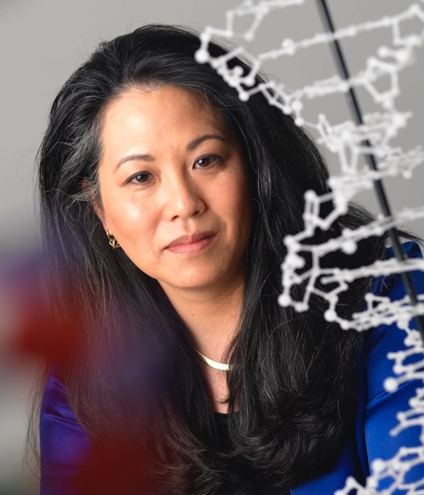
As a genetic counselor, geneticist, and psychologist, Vivian OTA WANG’s domestic and global experiences in research, education, science policy, and ethics span the psychological, genomic, nanoscale, and data sciences. She currently applies her expertise in race and racial identity, community engagement, and research participation protections to data access and sharing as the Policy and COVID Activities Lead at the Office of Data Sharing Strategy in the Division of Program Coordination, Planning, and Strategic Initiatives, Office of the Director at the National Institutes of Health (ODSS/OD- NIH). She is responsible for ethical and policy data sharing issues and is currently involved with establishing the NIH COVID Rapid Acceleration of Diagnostics (RADx) Data Repository for the RADx Initiative https://www.nih.gov/research-training/medical- research-initiatives/radx that is charged with accelerating innovation and development, commercialization, and implementation of COVD-19 testing through innovative diagnostic technologies, advancing late-state diagnostic technologies to expand testing infrastructure, identifying effective testing implementation strategies in underserved populations. She is also on-point for the concept and NIH Tribal Consultation for the RADx Tribal Data Repository https://dpcpsi.nih.gov/thro/tribal-consultations/tribal- data-repository, the first NIH independent, tribally directed and sovereignty-based research data repository for RADx American Indian/Alaska Native research data.

Previously, she served as the Deputy Director at the Office of Data Sharing in the Center for Biomedical Informatics and Information Technology at the National Cancer Institute- NIH. Additionally, was a Program Director for Data Access and Sharing and for the Ethical, Legal, and Social Implications Research Program at the National Human Genome Research Institute-NIH (NHGRI-NIH). Her other public service includes serving at the Executive Office of the President’s National Science and Technology Council under the Bush and Obama administrations where she developed public engagement and ethical, legal, and social guidance for nanoscience and nanotechnology and as a Senior Advisor to the NIH’s Office of Behavioral and Social Sciences Research Director

Prior to joining public service at the NIH, she was a practicing genetic counselor at the University of Colorado, and then held tenure-track faculty positions at Rutgers, Arizona State, and Vanderbilt universities where she maintained a research program focused on racial identity and multicultural competencies related to research ethics, program development and evaluation, and community engagement in psychology, genomics, and public health.

Dr. OTA WANG has served on national and international advisory committees, review panels, institutional review and editorial boards for US Federal agencies, and professional and international organizations including the US Department of Energy, US Food and Drug Administration, US Department of Agriculture, NIH, the American Association for the Advancement of Science, the United Nations Educational, Scientific, and Cultural Organization, the Organisation for Economic Co-operation and Development, the National Society of Genetic Counselors, and the American

Psychological Association. In 2020, she served as Guest Editor for the Journal of Genetic Counseling’s Minority of Minority and Health Disparities in Genetic Counseling Special Issues (Vol. 29, Issues, 2/3/4).

As the inaugural recipient of the National Society of Genetic Counselor’s (NSGC) Audrey Heimler Special Projects Fund, she created and implemented a multicultural competence-based curriculum, the Handbook of Cross-Cultural Genetic Counseling in US genetic counseling training programs. She also was responsible for the HapMap sample collections and community engagements for the self-identified Han Chinese in China and the US and was a voting member on the Food and Drug Administration’s (FDA), Cardiovascular and Renal Drugs Advisory Committee for BiDil™, the first FDA approved “race-specific” drug. She also served as Chair of of the National Society of Genetic Counselor’s Ethic Subcommittee, the American Psychological Association’s (APA) inaugural Committee on Human Research, Good Governance Project Implementation Working Group, and Commission on Ethical Processes that was charged with assessing and developing ethics policies and procedures in response to APA’s involvement with national security interrogations.

Dr. OTA WANG’s accomplishments have been recognized by university, professional, and national awards, honors and commendations including a Department of Health and Human Services Secretary’s Award for Distinguished Service, multiple NIH Director, National Human Genome Research Institute-NIH, and National Cancer Institute Director Awards, an NIH Sexual and Gender Minority Community & Ally Leadership Award, multiple NHGRI-NIH, NCI-NIH, and ODSS/OD-NIH Performance Merit Awards, an ODSS/OD-NIH On-the-Spot Award, the National Society of Genetic Counselors Audrey Heimler Special Projects Award, the Arizona State University’s Dean’s Faculty Award for Excellence in Diversity, the Colorado College Louis T. Benezet Award, the Teachers College-Columbia University Distinguished Alumni Award and the Asian American Psychological Association’s Distinguished Contributions Award. From the American Psychological Association, she has received a Presidential Citation, the Board of Scientific Affairs Meritorious Research Service Commendation, and the Charles and Shirley Thomas and Asuncion Miteria Austria and John Robinson Distinguished
Mentoring Awards.
H

Dr. OTA WANG received a BA in Biology (Colorado College), an MS in Genetic Counseling (University of Colorado) and an MPhil and PhD in Counseling Psychology (Columbia University). She is a Fellow of the American Medical Association (American College of Medical Genetics) and American Psychological Association (Divisions 17 & 45), Diplomate of the American Board of Medical Genetics and American Board of Genetic Counseling, a Clinical Laboratory Specialist in Cytogenetics, and a licensed psychologist.

