APA Distinguished Lecture: Suparna Rajaram, Ph.D.
SOCIAL REMEMBERING AND COLLECTIVE MEMORY FORMATION

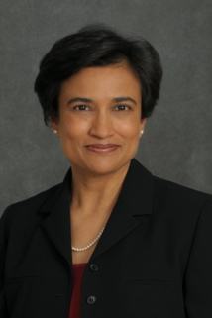

Chair:
Date and Time:

Abstract
As social animals, we routinely share past experiences with others. The emergent collective memories have long been topics of interest in history, anthropology, sociology, and social psychology. In cognitive science, interest in the transmission of memory in social settings can be traced back to Bartlett's seminal treatise in 1932. Yet, a century of research on memory has almost exclusively focused on individuals working in isolation largely inspired by Ebbinghaus (1885). My research group brings together these historic traditions to move from a study of individual memory to social memory. Our goal is to examine how social sharing shapes the post-collaborative memory of each group member and reciprocally shapes collective memory. A study of the nature of social memory is also timely in this digital age where people not only share and transmit memories in interpersonal face-to-face interactions but also on social media with a range of social connections. I will review data and theory from my lab to elucidate cognitive mechanisms that underlie memory enhancement as well as forgetting in shared remembering and the cascading effects of these changes on the emergence of collective memory.

Biosketch
Dr. Rajaram is Distinguished Professor at Stony Brook University, NY, USA. She studies human memory, with a particular interest in psychological mechanisms that influence memory transmission of true as well as false information and collective memory in groups and social networks. Her related research interests include a study of social remembering of emotional information, collaborative memory in aging, and the influence of culture on memory. Rajaram has served as President of the Association for Psychological Science (APS), member of APS’s Board of Directors, Chair of the Psychonomic Society’s Governing Board, Chair of the Psychonomic Society’s Publications Committee, Founding Chair of the APS Rising Stars committee, and member of NSF’s Behavioral and Cognitive Sciences Committee of Visitors. She is Co-founder of the international group Women in Cognitive Science that is supported by NSF to promote gender equity in cognitive sciences. Rajaram is a recipient of the Psychonomic Society’s inaugural Clifford T. Morgan Distinguished Leadership Award, the Visiting Scholar CLASS Award from Nanyang Technological University, Singapore, and the NIMH/FIRST award. She has been Associate Editor of Psychological Bulletin, Psychological Science, and Memory and Cognition. Rajaram is a fellow of APA, EPA, American Academy of Arts and Sciences, American Association for the Advancement of Science, APS, the Psychonomic Society, and the Society of Experimental Psychologists.

Behavioral Neuroscience Keynote: Mihaela Iordanova, Ph.D.
CORTICO-AMYGDALA REGULATION OF SECONDARY FEAR TRIGGERS

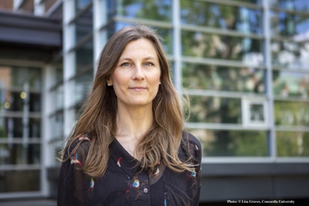

Chair: Travis Todd, Ph.D.
Date and Time: March 6 @ 10 AM

Abstract
The study of how the brain regulates learned fear has been fundamental to understanding brain function and has served as a pre-clinical animal model for fear- and anxiety-related disorders in humans. The current model has exclusively focused on primary triggers or cues for fear, that is, fear acquired through direct pairings between a cue and a fear-eliciting event. However, fear is also elicited by secondary triggers or cues, that is, cues that were never directly paired with the aversive event. These secondary cues gain fear-eliciting properties by virtue of their association with primary cues. The talk will present data showing how fear memories propagate across a memory network allowing for the development of secondary cues, how those memories are regulated by fear to the primary cues at the behavioural and neural level, as well as how they are supported by circuits in the brain.

Biosketch
Dr. Iordanova is an Associate Professor at Concordia University, a Canada Research Chair (Tier 2) in Behavioural Neuroscience, and a 2016 NARSAD Young Investigator. She obtained her PhD from the University of New South Wales, Sydney, Australia under the mentorship of Dr. Fred Westbrook where she studies the role of dopamine and opioid receptors in aversive prediction error. Subsequently, she studied the role of the perirhinal cortex and hippocampus in linking aversive memories to established complex with Dr Rob Honey at Cardiff University in Wales. During her time in the laboratory of Dr. Geoff Schoenbaum at the University of Maryland in Baltimore, USA, Dr Iordanova used in vivo electrophysiological recording to study how previously established memory are updated in the amygdala. In her own lab, Dr. Iordanova’s focuses on studying the role of dopamine in appetitive and aversive prediction error, as well as cortico-amygdala regulation of memory updating in fear and reward. In 2020, Dr. Iordanova was the recipient of the Canadian Association for Neuroscience Young Investigator Award.

Cognitive Psychology Keynote: Nora Newcombe, Ph.D.
LEARNING WITHOUT REMEMBERING? SEMANTIC BEFORE EPISODIC MEMORY IN DEVELOPMENT

Chair: Shaun Cook, Ph.D.
Date and Time: March 5 @1 PM

Abstract
Many memory models assume that semantic memory arises from abstraction over multiple episodic memories. However, developmental findings pose challenges to such models, because semantic memory develops considerably in advance of episodic memory. Children build an impressive vocabulary and learn many facts and concepts during periods when their memory for events is either lacking (infantile amnesia, 0-2 years) or fragile and fragmentary (childhood amnesia, 2-8 years). How is this possible? In this talk, I will present recent behavioral and neural evidence regarding this puzzle, and consider what new models and research are needed to resolve it completely.

Biosketch
Dr. Newcombe is Laura H. Carnell Professor of Psychology at Temple University. Dr. Newcombe earned her bachelor’s degree at Antioch College and her doctorate at Harvard University. Dr. Newcombe currently serves as Past President of the Federation of Associations in Brain and Behavioral Sciences (FABBS), as President of the International Mind Brain Education Society (IMBES), as Editor of Psychological Science in the Public Interest and as Associate Editor of Cognitive Research: Principles and Implications. Her numerous honors include the Distinguished Scientific Contributions Award from the Society for Research in Child Development, the William James Fellow Award from APS, the Howard Crosby Warren Medal from the Society of Experimental Psychologists, the George Miller Award and the G. Stanley Hall Awards from APA, the Award for Distinguished Service to Psychological Science, also from APA, and the Women in Cognitive Science Mentor Award. She is a fellow of four divisions of the American Psychological Association (General, Experimental, Developmental, and Psychology of Women), of the Association for Psychological Science, and of the American Association for the Advancement of Science. She is a member of the American Academy of Arts and Sciences and the Society of Experimental Psychologists.

Developmental Psychology Keynote: Natalie Brito, Ph.D.
NAVIGATING THE ABC’S OF DEVELOPMENTAL SCIENCE: INVESTIGATING INFANT DEVELOPMENT WITHIN APPLIED, BASIC, AND CULTURAL CONTEXTS

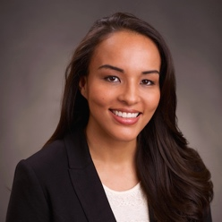
Chair: Kimberly Cuevas, Ph.D.
Date and Time: March 5 @ 2:30 PM

Abstract
It is well known that early experiences play a critical role in shaping trajectories of brain development and behavior. Research that examines how children learn from their caregivers and environments are needed, but more importantly, studies that incorporate culturally and linguistically diverse families are imperative to gain a fuller understanding of how basic learning mechanisms may vary across children’s experiences. Understanding the wider effects of the sociocultural context on development can potentially help to disentangle the many pathways through which adaptations to the environment impact brain and behavior. This talk will highlight two experiences common to many children: social inequality and multilingualism. These experiences will be discussed in relation to early neurocognitive development and potential impacts on societal values and public policies.

Biosketch
Dr. Brito is Assistant Professor in the Department of Applied Psychology at New York University (NYU). Dr. Brito earned her Doctoral degree in Psychology with a concentration in Human Development and Public Policy from Georgetown University in 2013. She then spent two years as a Robert Wood Johnson Health and Society Scholar and another two years as a postdoctoral research fellow within the Division of Developmental Neuroscience at Columbia University Medical Center. Dr. Brito’s research focus is on understanding how early social and cultural contexts shape the trajectory of neurocognitive development, with the goal of better understanding how to best support caregivers and create environments that foster healthy child development.

EPA Presidential Invited Address: Neil A Lewis, Jr., Ph.D.
FROM GOOD INTENTIONS TO INCLUSIVE ACTIONS: ACHIEVING THE DIVERSITY GOALS WE PROFESS

Chair: Bernard Beins, Ph.D.
Date and Time: March 5 @ 11:30 AM

Abstract
Academic and other scientific intuitions have spent much of the past few decades professing their values of diversity, equity, and inclusion, yet continue to struggle to recruit, promote, and retain people from some of the groups they profess to value. Why are these institutions that ostensibly value diverse communities unable to create and maintain them? In this talk I will discuss factors that undermine efforts to promote diversity in (scientific) organizations, and offer suggestions on paths forward for individuals, groups, and broader scientific institutions to take to create more diverse and inclusive institutions in the short, medium, and long-term.

Biosketch
Dr. Lewis is assistant professor at Cornell University and Weill Cornell Medicine. His research examines how social contexts and personal identities influence the motivation to pursue personal goals, and the success in goal pursuit efforts. He studies these processes most often in the domains of education, health, and environmental sustainability, in hopes that the knowledge generated from his research can provide useful insights for developing interventions to help people achieve their goals

.
EPA President Address: Bernard Beins, Ph.D.
CRITICAL THINKING: PSYCHOLOGY AND BEYOND
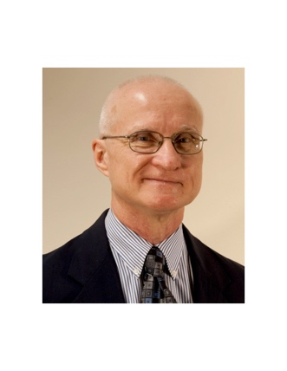
Chair: Amy Learmonth, Ph.D.
Date and Time: March 6 @ 11:30 AM

Abstract
Psychologists can tell us a lot about the ways people think. The past century has seen major advances in the theoretical understanding of our thought processes. Now it is important to understand how those processes actually play out in everyday life. With the seemingly boundless complexities in our lives, it becomes more important to recognize and apply principles of critical thinking to the way we make decisions and understand our world. Psychology can help with the answers.

Biosketch
Dr. Beins earned his doctorate in experimental psychology at the City University of New York and is professor of psychology at Ithaca College and currently, President of EPA. He has been president of the Society for the Teaching of Psychology (APA Division 2) and of the New England Psychological Association, and he is a Fellow of EPA, APS, APA and the New England Psychological Association (NEPA). He was director of Pre-College and Undergraduate Programs at APA and has served on APA’s Board of Educational Affairs and Council of Representatives. He has been on EPA’s Board of Directors and Program Committee and is currently the EPA historian. He has also been chair of the test development committees for the Psychology GRE and the Psychology Advanced Placement tests. He received the American Psychological Foundation’s Charles L. Brewer Distinguished Teaching Award and a career award from NEPA. His scholarship focuses on research methods, statistics, scientific literacy and scientific communication. He has authored or edited 11 traditional books, 7 e-books, and numerous journal articles and book chapters.

Clinical Psychology Keynote: Grace I. L. Caskie, Ph.D.
EXAMINING AGEISM AND HEALTHISM: THE GROWING NEED FOR COMPETENT MENTAL HEALTH CARE FOR OLDER ADULTS

Chair: Keith Morgen, Ph.D.
Date and Time: March 6 @ 10 AM

Abstract
Projected growth in the older adult population will increase the demand for mental health services tailored to meet older adults’ needs. Yet, relatively few clinicians specialize in geropsychology, and trainees often express little interest in this area, pointing to a widening gap in the ability to provide competent care to older adults. Ageism, healthism, aging anxiety, contact with older adults, and other factors that may explain variability in psychology trainees’ interest in future work with older adults and clinical bias toward older adults will be discussed as well as how training programs might increase the number of future geropsychologists.
Biosketch
Dr. Caskie is associate professor at Lehigh University and director of the counseling psychology program. Her scholarship focuses on the use of advanced quantitative methods to examine issues related to gerontology with a particular focus on ageism, health, and cognition.

Fred S. Keller Distinguished Lecture: Warren Bickel, Ph.D.
REINFORCER PATHOLOGY: THE BEHAVIORAL ECONOMICS OF ADDICTION & OBESITY

Chair: Jef Lamoureux
Date and Time: March 6 @ 1 PM

Abstract
Reinforcer pathology, a recent development in the field of behavioral economics, specifies that (1) reinforcers are integrated over time, (2) the length of the window of integration can vary, and, in turn, (3) alter the valuation of different reinforcers. Short temporal windows of integration will increase the value of intense, reliable, and brief reinforcers such as drugs and obesogenic foods while leading to a decline in the value of less intense, variable reinforcers that extend over time, such as prosocial reinforcers (e.g., relationships). Conversely, long temporal windows of integration should result in a reversal in the valuation of drug and prosocial reinforcers. Importantly, reinforcer pathology suggests a novel approach to treatment, namely, to increase the length of the temporal integration window. In this presentation, this model and data supporting it will be reviewed.

Biosketch
Dr. Bickel is the Virginia Tech Carilion Behavioral Health Research Professor; Director, Addiction Recovery Research Center; and Director, Center for Transformative Research on Health Behaviors. Dr. Bickel’s current research is exploring new methods for helping people with alcohol use disorder.

Applied Psychology Keynote: Jasmine Mena, Ph.D.
COPING SKILLS ARE NECESSARY, BUT NOT SUFFICIENT: THE INFLUENCE OF CULTURE AND CONTEXT ON THE PSYCHOLOGICAL ADJUSTMENT OF BLACK LATINXS

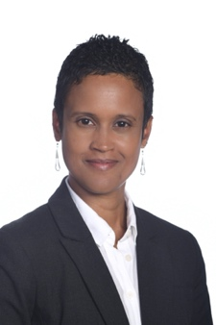

Chair: Jennifer Thompson
Date and Time: March 5 @ 2;30 PM

Abstract
Professor Mena will discuss the influence that cultural and contextual factors have on the psychological adjustment of Latinxs. A central concern in her research pertains to the racialized experiences of the diverse Latinx population and the (un)known health implications. Specifically, in her talk she will present research on racial differences associated with perceived discrimination, skin tone perception and satisfaction, racial identity, and cultural socialization practices within the Latinx community. Understanding the influence of cultural and contextual factors is essential for targeting treatment and crafting policies to reduce health disparities.

Biosketch
Dr. Mena (Assistant Professor, Bucknell University) is a clinical psychologist whose research examines the influence of cultural and contextual factors on physical and mental health. She is especially interested in illuminating the experiences of historically marginalized groups and strives to apply research findings in community settings. She has a passion for working with students on research from conceptualization to publication and every step in between.

Teaching of Psychology/International/Psi Chi Keynote: Kurt F. Geisinger, Ph.D.
DO PSYCHOLOGICAL TESTS AND ASSESSMENTS KNOW FOREIGN LANGUAGES?

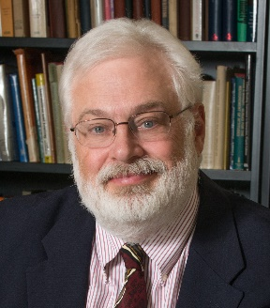

Chair: Harold Takooshian, Ph.D.
Date and Time: March 6 @ 2:30 PM

Abstract
Testing has been "big business" for many years in clinical, educational, industrial, and medical settings. While it has been "big business" in the United States for many years, testing has also approached and even attained that status in other developed countries throughout the world. There are some issues with which one must deal in adapting tests for different countries, cultures, and languages. This presentation suggests how test developers can adapt tests appropriately to serve these new and different settings validly. I will present examples of successful adaptations as well as examples of items that fail to replicate in different languages. The body of the presentation details different ways that psychologists and test developers can implement test construction and adaptation efforts to maximize procedures so that tests will provide valid results in new cultures and languages. These examples of test adaptation procedures and items that do not work when translated from an original language to a target language will make examples that professors can use to add cross-cultural depth to appropriate psychology classes. I will also discuss situations where we should replicate psychometric procedures in the new lands.

Bioketch
Dr. Geisinger is Director of the Buros Center on Testing and W. C. Meierhenry Distinguished University Professor at the University of Nebraska. He is a noted teacher, scientist, and leader within International Psychology. Geisinger’s primary interests lie in validity theory, admissions testing, proper test use, test use with individuals with disabilities, the testing of language minorities and the translation or adaptation of tests from one language and culture to another.

Learning Keynote: Yael Niv, Ph.D.
LATENT CAUSES, PREDICTION ERRORS, AND THE ORGANIZATION OF MEMORY

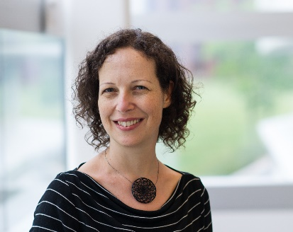

Chair: Eric Thrailkill, Ph.D.
Date and Time: March 5 @ 1 PM

Abstract
In recent years, my lab has suggested that incoming information is parsed into separate clusters ("states" in reinforcement learning parlance) -- all events that are assigned to one cluster are learned about together, whereas events in different clusters do not interfere with each other in learning. Moreover, we have suggested that prediction errors are key to this separation into clusters. In this talk, I will revisit these ideas building not only on behavioral experiments showing evidence for clustering, but also experiments that show the effects of prediction errors on episodic memory. I will attempt to tie the different findings together into a hypothesis about how prediction errors affect not only learning, but also the organization of memory.

Biosketch
Dr. Niv received her MA in Psychobiology from Tel Aviv University and her PhD in Computational Neuroscience from the Hebrew University in Jerusalem, having conducted a major part of her thesis research at the Gatsby Computational Neuroscience Unit in UCL. She is currently a professor at Princeton University, at the Psychology Department and the Princeton Neuroscience Institute. Her lab's research focuses on the neural and computational processes underlying reinforcement learning and decision making, with a particular focus on how the cognitive processes of attention, memory and learning interact in constructing task representations that allow efficient learning and decision making. She is co-founder and co-director of the Rutgers-Princeton Center for Computational Cognitive Neuropsychiatry, where she is applying ideas from reinforcement learning to questions pertaining to psychiatric disorders within the new field of computational psychiatry.

Social Psychology Keynote: Regan A.R. Gurung, Ph.D.
ROLLING WITH THE PUNCHES OF COVID ET AL.: PSYCHOLOGICAL SCIENCE TRAINING TIPS

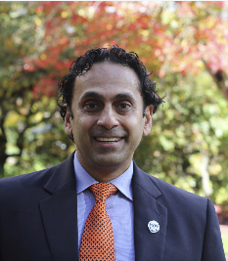
Chair:
Date and Time:

Abstract
Over the last year, we have all had numerous punches thrown our way with COVID, natural disasters, political animosity, and the fight for racial equality. Psychological science and health psychology in particular have addressed stress and coping for over 40 years and some of this research nicely spilled into mainstream media. In this talk I review key psychological theories and phenomenon that can help us better cope and move forward.

Biosketch
Dr. Gurung is a social psychologist by training and with research encompassing social, health, and pedagogical psychology. He has had over 100 articles published in peer-reviewed journals and has co-authored/co-edited 15 books. He is founding co-editor of APA’s journal Scholarship of Teaching and Learning in Psychology, co-chairs the APA General Psychology Initiative, and is currently past president of Psi Chi, the International Honor Society in Psychology. At Oregon State University, he is Interim Executive Director of the Center for Teaching and Learning, Professor of Psychological Science, and Director of the General Psychology Program.

History of Psychology Keynote: Jill Morawski, Ph.D.
LOOPING, CREEPING, AND ENACTING: HOW DO PSYCHOLOGICAL PHENOMENA CHANGE?

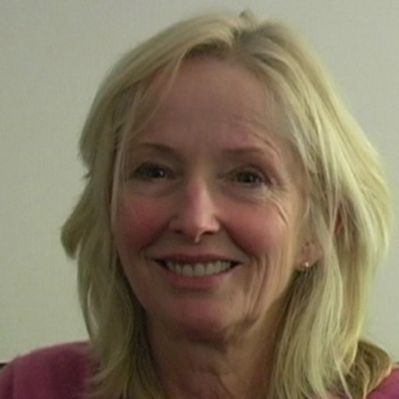

Chair: Darryl Hill, Ph.D.
Date and Time: March 6 @ 1 PM

Abstract
The history of psychology has centered around the discovery, development and sometimes the demise of scientific knowledge about psychology’s objects. Historians generally follow psychological scientists in assuming that these discovered, calibrated, and classified psychological phenomena, (if found to be valid or ‘real’) are stable, enduring objects. Yet significant studies – empirical, theoretical, and historical – suggest that psychology’s phenomena or at least not all psychological phenomena are so permanent: they can vary over time and place. Further, these studies indicate that changes in phenomena might be due not only to changing material and cultural contexts but also to psychology itself and to the individuals who learn about and engage psychological knowledge. Phenomena and knowledge about them are observed to “loop,’ “creep” and otherwise be “enacted” outside laboratories. This presentation offers a synthetic and critical perspective on the very idea that psychology’s ontology is dynamic, asking if, when, and how phenomena change. It invites open investigation of the consequences of such ontological transformations when they occur and proposes that better understanding of dynamic phenomena can provide generative frameworks for research.

Biosketch
Dr. Morawski is Willbur Fisk Osborne Professor of Natural Science and Professor of Psychology at Wesleyan University. She studies the history of modern psychological sciences with focus on the scientific practices accompanying claims about the nature of subjectivity and the moral commitments of scientific psychology.

Community Psychology Keynote: Nkiru Nnawulezi, Ph.D.
STRUCTURAL RACISM ACROSS THE DOMESTIC VIOLENCE HOUSING CONTINUUM

Chair: Robey Champine, Ph.D., M.S., MPH
Date and Time: March 5 @ 11 AM

Abstract
Intimate partner violence (IPV), housing instability, and anti-Black racism independently and simultaneously threaten the well-being of individuals and communities. In this talk, I will discuss how structural intersectionality and empowerment theories informed the conceptualization and development of studies centering the lives of primarily Black women survivors. I employ a community-grounded, Black feminist lens to examine survivors’ complicated relationships with domestic violence-specific housing institutions and systems that are fraught with legacies of racism, classism, and sexism. Transformative community-based, participatory research approaches directly reveal, respond, and seek to transform these legacies by deepening knowledge about complex systems, building collective consciousness and capacities, and strengthening community-derived interventions. Overall, findings from these studies provide valuable insights, challenges, and opportunities to create greater, and more equitable, access to safe and stable housing for survivors who experience multiple marginalization.

Biosketch
Dr. Nnawulezi is Assistant Professor at the University of Maryland, Baltimore County and Affiliate Faculty at the Yale School of Public Health. She earned her doctorate in Ecological-Community Psychology at the Michigan State University and has additional graduate certifications in college teaching, community engagement, and quantitative research methods. Her research examines the ecological factors that enhance equity within and across the domestic violence housing continuum. She aims to improve social and material conditions for survivors of gender-based violence who occupy multiply marginalized social identities. Dr. Nnawulezi also seeks to develop sustainable survivor-centered, community-based systems of support that can serve as alternatives to traditional social service systems. Her work has been funded by the National Institute of Mental Health, State of Michigan, and Center for Victim Research. She is an award-winning researcher and mentor and has disseminated her scholarship to academic and community audiences through peer-reviewed articles, book chapters, technical reports, invited academic and community talks, and national and international conferences. As an expert in community-based, participatory research and trained facilitator, Dr. Nnawulezi designs participatory research processes with community partners to find innovative solutions to complex social problems. She serves as an Associate Editor for the Journal of Family Violence and is on the editorial board of the Community Psychology in the Global Perspective Journal. She is also a Research and Evaluation Advisor to multiple community and systems change organizations such as the National Resource Center on Domestic Violence, DC Coalition Against Domestic Violence, National Innovative Service, and Ujima: The National Center on Violence Against Women in the Black Community.

