Suparna Rajaram (Stony Brook University)
APA Distinguished Lecturer
Social Remembering and Collective Memory Formation
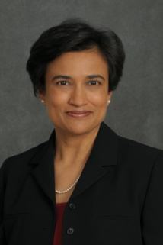

Mihaela Iordanova (Concordia University)
Behavioral Neuroscience Keynote
Cortico-amygdala regulation of secondary fear triggers
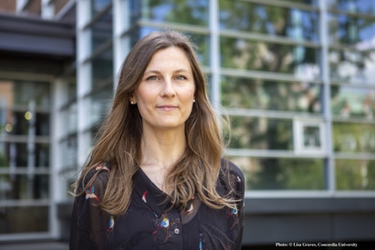

Nora Newcombe (Temple University)
Cognitive Psychology Keynote
Learning without remembering? Semantic before episodic memory in development
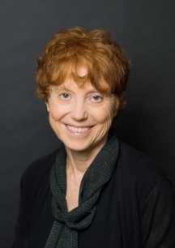

Natalie Brito (NYU)
Developmental Psychology Keynote
Navigating the ABC’s of Developmental Science: Investigating Infant Development within Applied, Basic, and Cultural Contexts

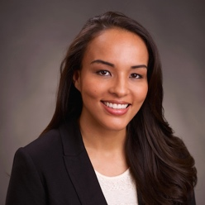

Bernard Beins (Ithaca College)
EPA Presidential Address

Neil A Lewis, Jr (Cornell University)
Presidential Invited Address

Warren Bickel (Virginia Tech)
Fred S. Keller Distinguished Lecturer

Jasmine Mena (Bucknell University)
Applied Psychology Keynote

Jill Morawski (Wesleyan University)
History of Psychology Keynote

Kurt F. Geisinger (Director, Buros Center)
Teaching of Psychology/International Keynote

Yael Niv (Princeton University)
Learning Keynote

Psi Chi Invited Speaker TBA
Social Psychology Keynote TBA
Clinical Psychology Keynote TBA
Community Psychology Keynote TBA

