Suparna Rajaram (Stony Brook University)
APA Distinguished Lecturer
Social Remembering and Collective Memory Formation
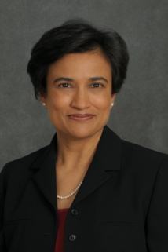

Mihaela Iordanova (Concordia University)
Behavioral Neuroscience Keynote
Cortico-amygdala regulation of secondary fear triggers
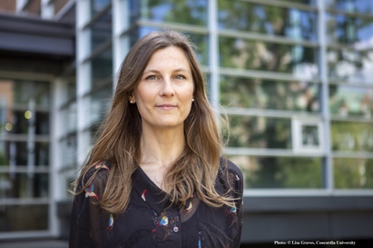

Nora Newcombe (Temple University)
Cognitive Psychology Keynote
Learning without remembering? Semantic before episodic memory in development
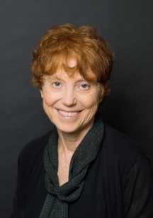

Natalie Brito (NYU)
Developmental Psychology Keynote
Navigating the ABC’s of Developmental Science: Investigating Infant Development within Applied, Basic, and Cultural Contexts

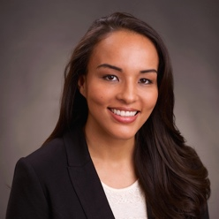

Neil A Lewis, Jr (Cornell University)
Presidential Invited Address

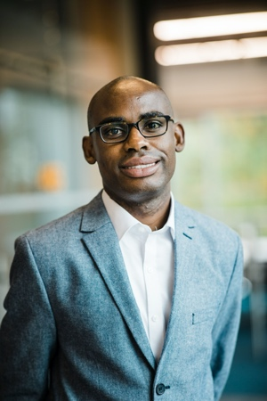

Neil Lewis, Jr. is an assistant professor at Cornell University and Weill Cornell Medicine. His research examines how social contexts and personal identities influence the motivation to pursue personal goals, and the success in goal pursuit efforts. He studies these processes most often in the domains of education, health, and environmental sustainability, in hopes that the knowledge generated from his research can provide useful insights for developing interventions to help people achieve their goals.

Bernard Beins (Ithaca College)
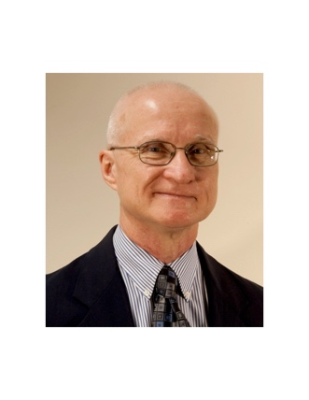
EPA Presidential Address
Dr. Beins is Professor of Psychology at Ithaca College and the President of EPA. His scholarship focuses on research methods, statistics, scientific literacy and scientific communication.

Warren Bickel (Virginia Tech)
Fred S. Keller Distinguished Lecturer
Dr. Bickel is the Virginia Tech Carilion Behavioral Health Research Professor; Director, Addiction Recovery Research Center; and Director, Center for Transformative Research on Health Behaviors. Dr. Bickel’s current research is exploring new methods for helping people with alcohol use disorder.

Jasmine Mena (Bucknell University)
Applied Psychology Keynote
Dr. Mena (Assistant Professor, Bucknell University) is a clinical psychologist whose research examines the influence of cultural and contextual factors on physical and mental health. She is especially interested in illuminating the experiences of historically marginalized groups and strives to apply research findings in community settings. She has a passion for working with students on research from conceptualization to publication and every step in between.

Jill Morawski (Wesleyan University)
History of Psychology Keynote
Dr. Morawski is Willbur Fisk Osborne Professor of Natural Science and Professor of Psychology at Wesleyan University. She studies the history of modern psychological sciences with focus on the scientific practices accompanying claims about the nature of subjectivity and the moral commitments of scientific psychology.

Kurt F. Geisinger (Director, Buros Center)
Teaching of Psychology/International Keynote
Dr. Geisinger is Director of the Buros Center on Testing and W. C. Meierhenry Distinguished University Professor at the University of Nebraska. His primary interests lie in validity theory, admissions testing, proper test use, test use with individuals with disabilities, the testing of language minorities and the translation or adaptation of tests from one language and culture to another.

Yael Niv (Princeton University)
Learning Keynote
Dr. Niv is Professor of Psychology and Neuroscience at Princeton University. She is also co-director of the Rutgers-Princeton Center for Computational Neuropsychiatry . Her research efforts are aimed at understanding how learning interacts with memory in the brain with the goal of using basic research findings to ameliorate the effects of traumatic experiences and maladaptive learning (e.g., addiction).

Psi Chi Invited Speaker TBA
Social Psychology Keynote TBA
Clinical Psychology Keynote TBA
Community Psychology Keynote TBA

